Minimum shot value: 🡪 based on our epsilon value 🡪 Chapter 4 of the source book

* We can say we have a shot list 🡪 we may be given 3 results🡪

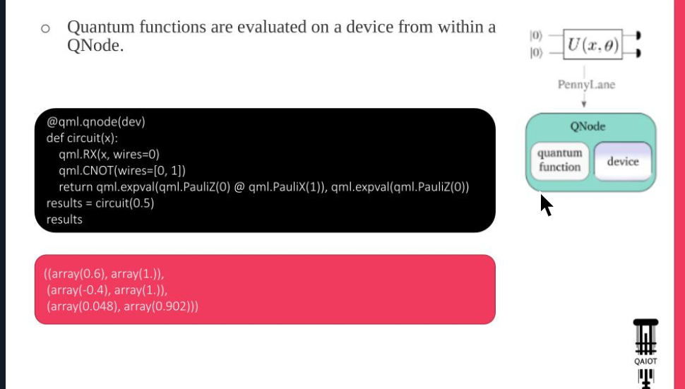

Bonus: Till Thursday 🡪 before Lab session

* Initialization starts with ket 0! 🡪 whatever Qbit I desire!

Good link for Pennylane differentiation methods:

[**https://docs.pennylane.ai/en/stable/introduction/interfaces.html**](https://docs.pennylane.ai/en/stable/introduction/interfaces.html)

Numpy compatible interface 🡪 autograd 🡪 interface=’autograd’

Use ‘default-qubit’ or ‘real-hardware’ for device in

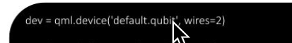

Figure 1

When I use interface, I interpret Quantum states for classical methods!

* We use Numpy based interface!
* Device is what we run our quantum circuit over it!

Use this style when coding:

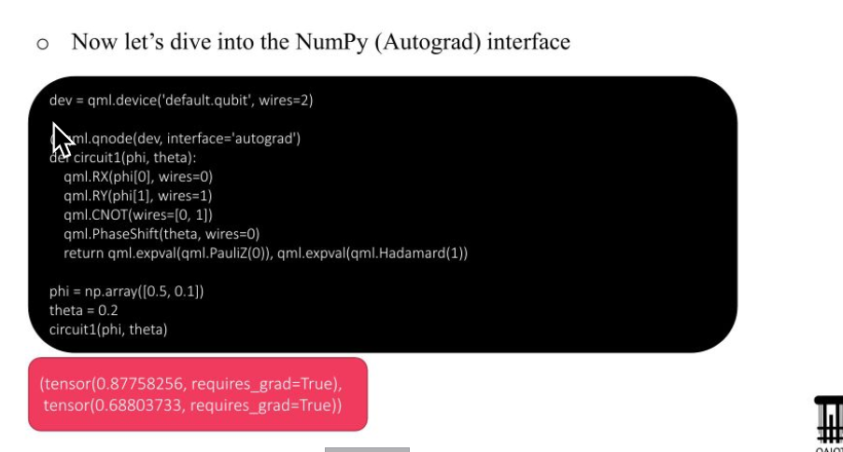

calculate expectation values theoretically and manually and then compare it for various shots!

* Parameters phi and theta 🡪 wires 🡪 means the Q-Bit we use!
* Why we use Hadamard or PaulZ measurements?

[**https://scholar.google.es/citations?hl=en&user=I8mtxEAAAAAJ&view_op=list_works&sortby=pubdate**](https://scholar.google.es/citations?hl=en&user=I8mtxEAAAAAJ&view_op=list_works&sortby=pubdate)

Observable:

* Any Matrice that is k*k Hermitian matrix.

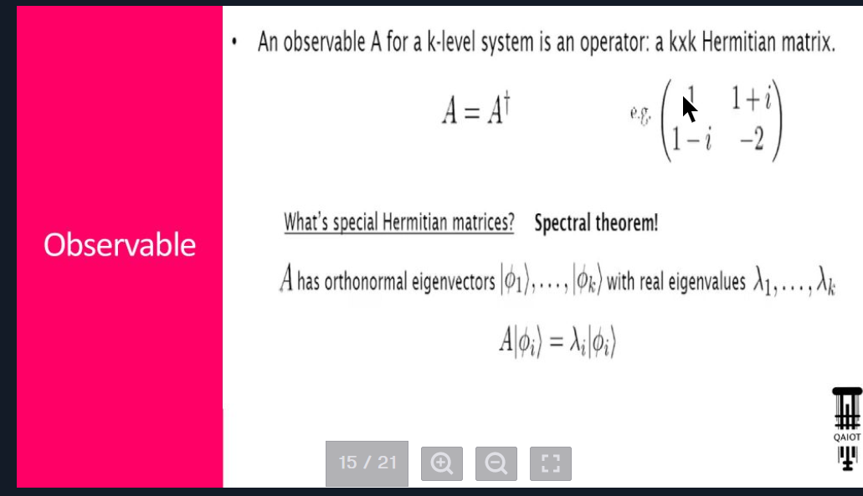

Niels Bohr and Max Planck, two of the founding fathers of Quantum Theory, each received a Nobel Prize in Physics for their work on quanta.

David Deutsch, father of quantum computing.

# Quantum:

## Quantum Gates:

List of all quantum gates:

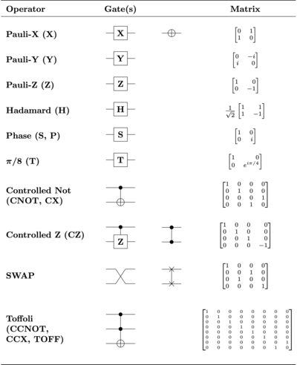

Figure 2

### Pauli Gates:

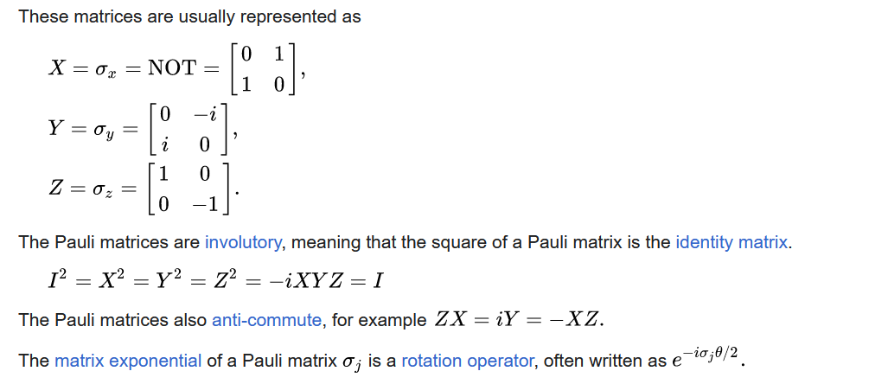

Figure 3

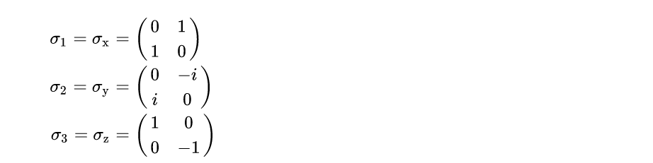

Figure 4

### CNOT:

The CNOT (or controlled Pauli-X) gate can be described as the gate that maps the basis states | a , b ⟩ ↦ | a , a ⊕ b ⟩ where ⊕ is XOR.

Controlled gates act on 2 or more qubits, where one or more qubits act as a control for some operation.

For example, the controlled NOT gate (or CNOT or CX) acts on 2 qubits and performs the NOT operation on the second qubit only when the first qubit is | 1 ⟩, and otherwise leaves it unchanged.

With respect to the basis | 00 ⟩, | 01 ⟩, | 10 ⟩, | 11 ⟩, it is represented by the Hermitian unitary matrix:

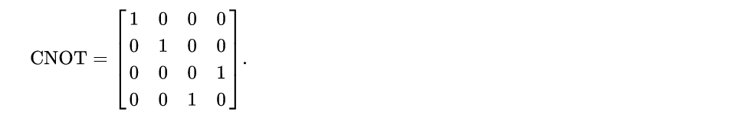

Figure 5

* Quantum states are typically represented by "kets", from a notation known as bra-ket.

The vector representation of a single qubit is:

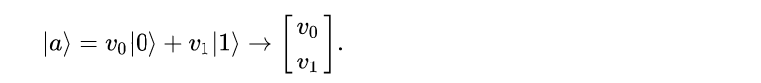

Figure 6

Here, $ν_{0}$ and $ν_{1}$ are the complex probability amplitudes of the qubit. These values determine the probability of measuring a 0 or a 1, when measuring the state of the qubit. See measurement below for details.

### Hadamard

* While the Pauli gates are a lot like classic logic gates in some respects, the Hadamard gate, or H-gate, is a bona fide quantum beast. It shows up everywhere in quantum computing, and for good reason.
* The Hadamard gate has the characteristically quantum capacity to transform a definite quantum state, such as spin-up, into a murky one, such as a superposition of both spin-up and spin-down at the same time.

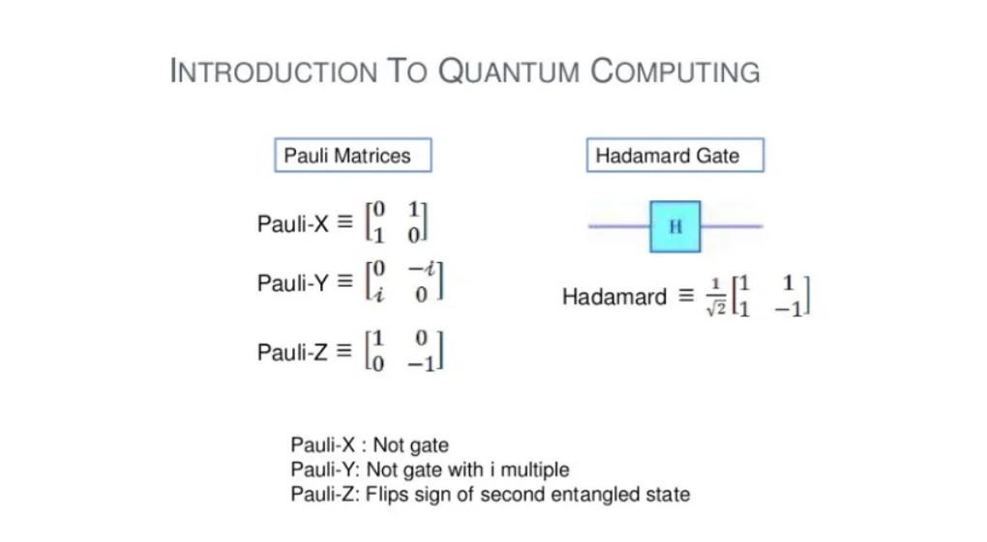

Figure 7

### Table of Quantum Gates:

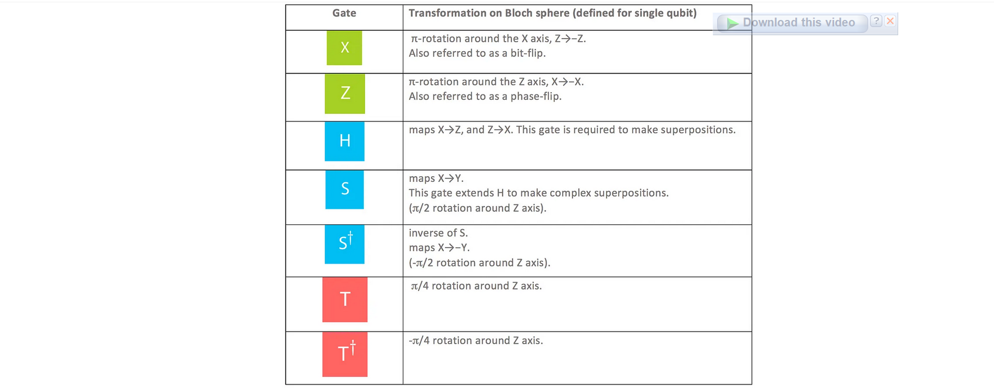

Figure 8

## Vector Rep. of 2 qubits:

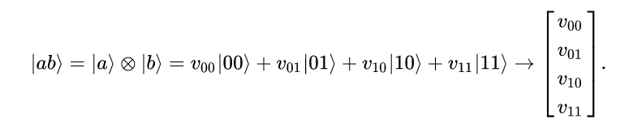

Figure 9

## Applying Gates to states:

The action of the gate on a specific quantum state is found by multiplying the vector $| Ψ_{1}>$, which represents the state by the matrix U representing the gate. The result is a new quantum state $|Ψ_{2}>$:



Figure 10

## Projection:

$$P=\left|Φ><Φ\right|;$$

$$P\left|ψ> =\left|Φ><Φ\right| \right|ψ>$$

Example:

$$|Φ_{1}> = \frac{1}{\sqrt{2}}|0>+\frac{i}{\sqrt{2}}|1>$$

$λ_{1}=1;$

$$|Φ_{2}> = \frac{1}{\sqrt{2}}|0>-\frac{i}{\sqrt{2}}|1>$$

$λ_{2}=-1;$

$$A=λ_{1}.\left|Φ_{1}×Φ_{1}\right|+λ_{2}.\left|Φ_{2}×Φ_{2}\right|$$

$A|Φ_{1}> =$

$$\left(1.\left|Φ_{1}×Φ_{1}\right|-1.\left|Φ_{2}×Φ_{2}\right|\right)\left|Φ_{1}> =\left|Φ_{1}×Φ_{1}\right|\right|Φ_{1}>-\left|Φ_{2}×Φ_{2}\right| {|Φ}_{1}>$$

$$=1.|Φ_{1}>$$

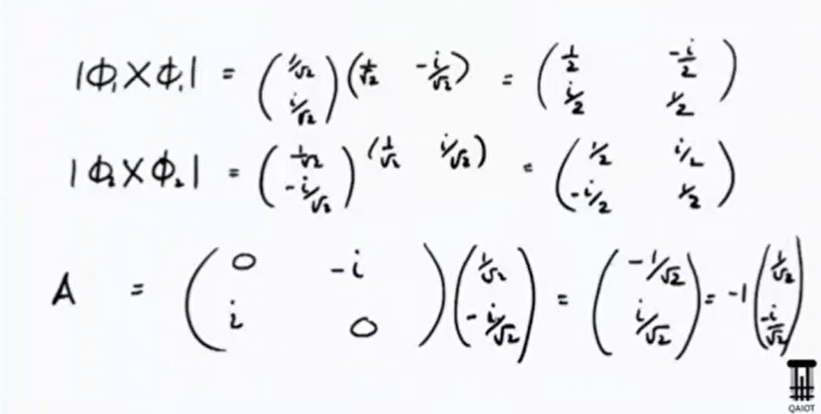

Figure 11

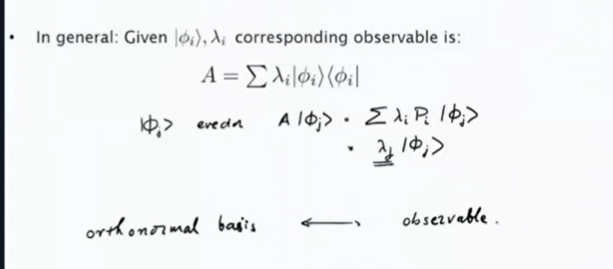

Figure 12

## Bloch Sphere:

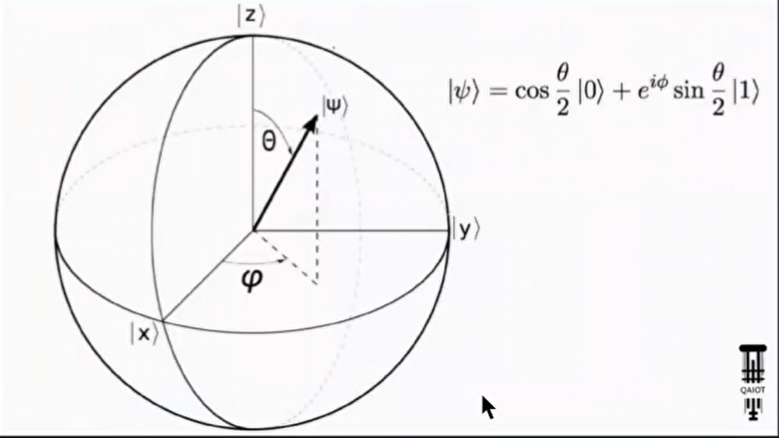

Figure 13

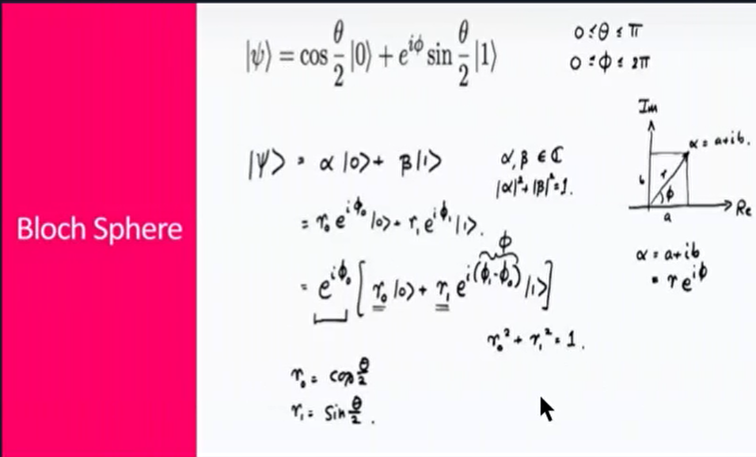

Figure 14

## Quantum States:

|+> ::::

|-> ::::

|0> ::::

|1> :::: ${\left[0 , 1\right]}^{T}$

* The quantum state after a measurement is in an eigenstate corresponding to that measurement.
* Repeating the measurement will not alter the state.
* Complementary measurements further refine the state, causing it to be an eigenstate corresponding to other measurements.
* A full set of complementary measurements produces a pure state.
* Any state that is not pure is called a mixed state.
* The quantum plus state is denoted by the ket |+⟩, and the quantum negative state is denoted by the ket |-⟩.
* The quantum plus state is a normalized state that is orthogonal to the quantum negative state. This means that the inner product of the quantum plus state and the quantum negative state is equal to zero.
* The quantum plus and negative states are often used to represent the two possible states of a quantum system, such as the up and down states of a spin-1/2 particle.

1. The vacuum state: |0⟩, which is the state with no particles.
2. The excited state: |1⟩, which is the state with one particle.
3. The coherent state: |α⟩, which is a state that is a superposition of the vacuum state and the excited state.
4. The squeezed state: |ψ⟩, which is a state that has been squeezed in one of its dimensions.
5. The entangled state: |ψ⟩, which is a state that is shared by two or more particles.

* Quantum mechanics is linear. This means that the superposition principle holds, which states that the state of a quantum system is the sum of the states of its constituent parts.
* The state of a spin-1/2 particle can be represented by the ket |↑⟩ or the ket |↓⟩, which represent the up and down spin states, respectively.
* The state of a two-level atom can be represented by the ket |0⟩ or the ket |1⟩, which represent the ground and excited states, respectively.
* The state of a photon can be represented by the ket |α⟩ or the ket |β⟩, which represent the two polarization states, respectively.

### Tensor Product of States

[https://www.quora.com/Why-is-00-1-0-0-0-*-in-linear-algebra-bra-ket-notation](https://www.quora.com/Why-is-00-1-0-0-0-*-in-linear-algebra-bra-ket-notation)

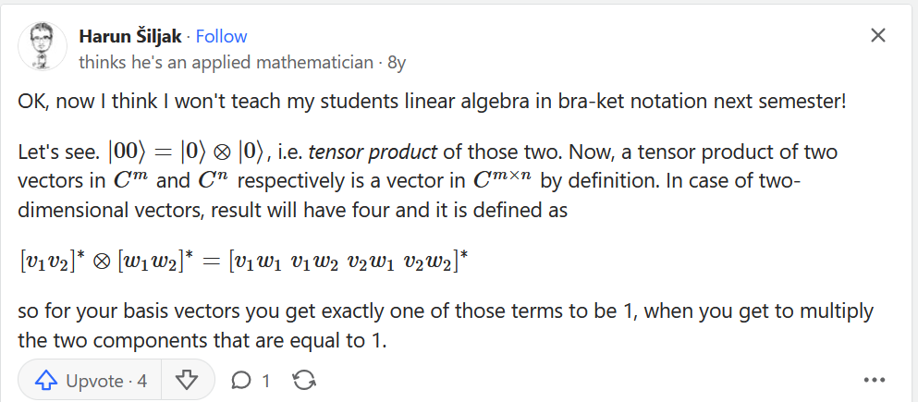

Figure 15

$\left|0> ⨂{|0> = }\right|00> =\left[1 0\right]'*\left[1 0\right]'=[1 0 0 0]$

## Quantum Embeddings:

### From: <https://research.ibm.com/publications/current-state-of-embedding-techniques-for-quantum-computing>

Embedding is a method of combining classical and quantum computing techniques to explore problems which typically have a natural center or centers of strongest or more correlated interactions, and this part/parts are done on the quantum computer, while the rest is done with a classical system. The goal is usually either greater accuracy, greater speed, or greater opportunity for analytical insight into the system. What distinguishes embedding techniques is usually the proportion and frequency of interchange between quantum and classical techniques.

### From: <https://g.co/bard/share/9f2507f1b27c>

There are many parametric quantum embedding methods, and it is difficult to name all of them. However, here are some of the most common ones:

* Variational quantum classifier (VQC)

* Amplitude embedding

* Gaussian embedding

* Fourier embedding

* Haar embedding

* Discrete Fourier transform embedding

* Principal component analysis embedding

* Low-rank embedding

* Tensor embedding

* Graph embedding

* Variational quantum autoencoder (VQAE)

* Quantum Boltzmann machine (QBM)

* Quantum restricted Boltzmann machine (QRBM)

* Quantum deep learning network (QDL)

* Quantum generative adversarial network (QGAN)

These are just a few of the many parametric quantum embedding methods that are currently being developed. As quantum computing technology continues to improve, we can expect to see even more powerful and efficient quantum embedding methods being developed in the future.

It is important to note that the effectiveness of a particular parametric quantum embedding method depends on the specific task at hand. For example, the VQC method is well-suited for classification tasks, while the Gaussian embedding method is well-suited for regression tasks.

The choice of parametric quantum embedding method also depends on the available quantum hardware. For example, some methods are more computationally expensive than others, and some methods require more qubits than others.

Overall, the field of parametric quantum embedding is still in its early stages of development. However, the methods that are currently available have shown great promise for solving a variety of machine learning problems.

### From: <https://g.co/bard/share/bbde336a9778>

Quantum embeddings are a technique in quantum machine learning that maps classical data into a quantum state. This allows quantum algorithms to be applied to the data, which can lead to improved performance.

There are two main types of quantum embeddings:

* **Parametric quantum embeddings:** These embeddings use a parametric quantum circuit to map the data into a quantum state. The parameters of the circuit can then be trained to optimize the embedding for a particular task.

* **Non-parametric quantum embeddings:** These embeddings use a fixed quantum circuit to map the data into a quantum state. The data is then encoded into the state of the quantum system by measuring the system in a particular basis.

Here are some of the available quantum embedding methods:

* **Variational quantum classifier (VQC):** This is a parametric quantum embedding method that uses a variational algorithm to train the parameters of the quantum circuit. The VQC has been shown to be effective for classification tasks.

* **Quantum kernel methods:** This is a non-parametric quantum embedding method that uses a quantum circuit to implement a kernel function. Kernel functions are used in machine learning to measure the similarity between two data points. The quantum kernel methods have been shown to be effective for regression tasks.

* **Quantum neural networks:** This is a parametric quantum embedding method that uses a quantum circuit to implement a neural network. Quantum neural networks have been shown to be effective for a variety of tasks, including classification, regression, and natural language processing.

Here are the links to the original articles proposing the corresponding methods:

* Variational quantum classifier: https://arxiv.org/abs/1608.03995

* Quantum kernel methods: https://arxiv.org/abs/1806.08869

* Quantum neural networks: https://arxiv.org/abs/1802.06082

Here is a step-by-step explanation of the VQC method:

1. The classical data is represented as a vector of real numbers.

2. A variational quantum circuit is initialized with random parameters.

3. The quantum circuit is applied to the data vector, producing a quantum state.

4. The quantum state is measured, yielding a classical output.

5. The parameters of the quantum circuit are updated using a gradient-based optimization algorithm.

6. Steps 3-5 are repeated until the accuracy of the classifier converges.

The VQC method can be used to solve a variety of machine learning problems, including classification, regression, and clustering. The method is still under development, but it has shown promise for solving problems that are difficult or impossible to solve with classical machine learning methods.

I hope this helps! Let me know if you have any other questions.

### From: QAIOT Sessions

Embeddings encode input features into the quantum state of the circuit. Hence, they usually take a data sample such as a feature vector as an argument. Embeddings can also depend on trainable parameters, and they may be constructed from repeated layers.

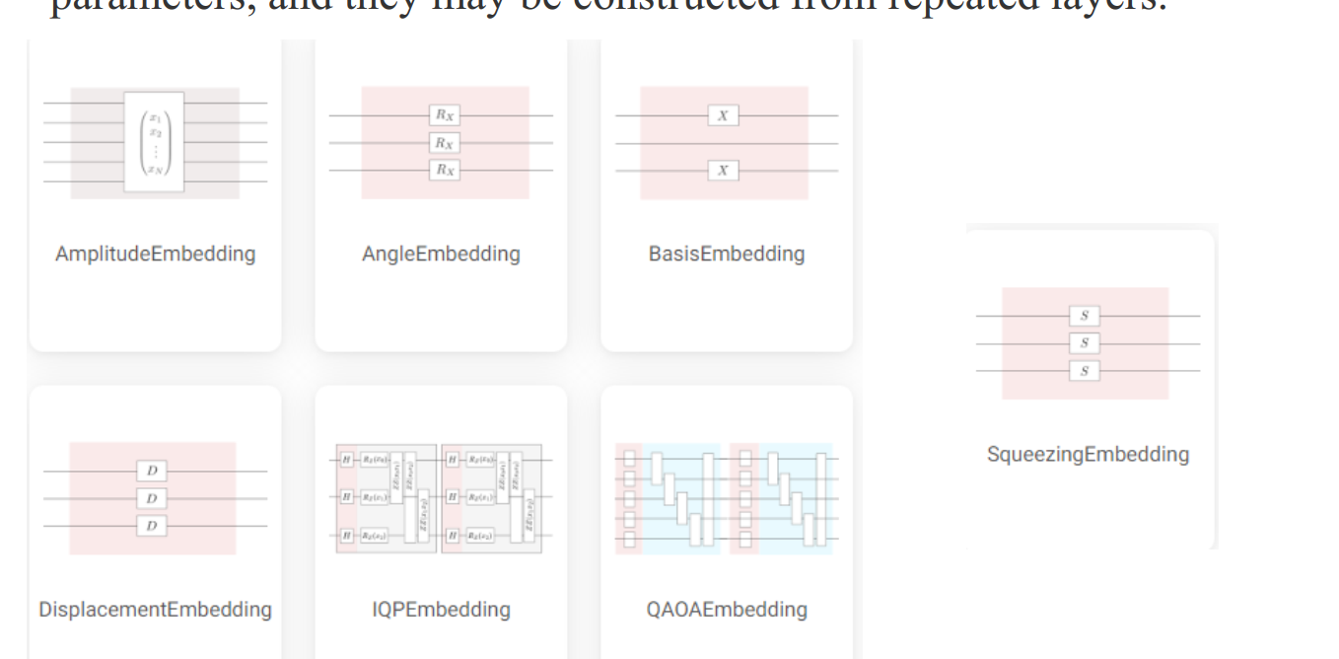

Figure 16

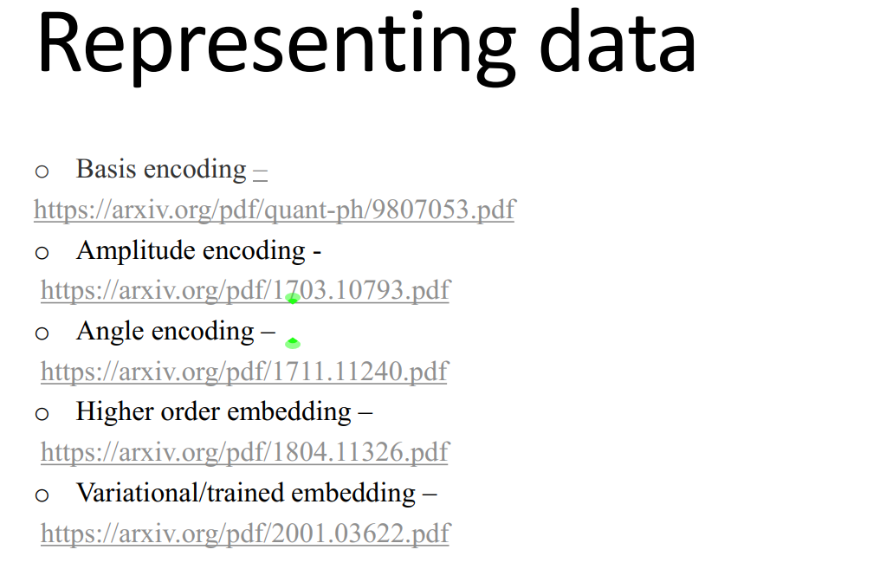

Figure 17

### Amplitude Embedding:

AmplitudeEmbedding: 

Figure 18

✓ encodes $2^{n}$ features into the amplitude vector of n qubits.

✓ By setting pad_with to a real or complex number, features is

automatically padded to dimension $2^{n}$ where n is the number of qubits

used in the embedding.

✓ To represent a valid quantum state vector, the L2-norm of features

must be one. The argument normalizes can be set to True to

automatically normalize the features.

✓ If both automatic padding and normalization are used, padding is

executed before normalizing.

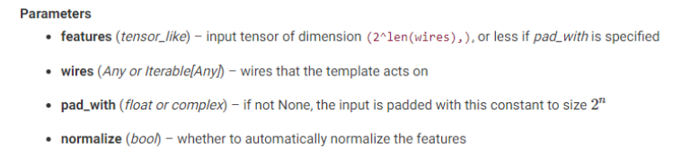

Figure 19

Amplitude embedding encodes a normalized 2-dimensional feature

vector into the state of n qubits:

1. import pennylane as qml

2. dev = qml.device('default.qubit', wires=2)

3. @qml.qnode(dev)

4. def circuit(f=None):

5. qml.AmplitudeEmbedding(features=f, wires=range(2))

6. return qml.expval(qml.PauliZ(0))

7. circuit(f=[1/2, 1/2, 1/2, 1/2])

8. dev.state

9.

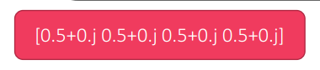

Figure 20

The template will raise an error if the feature input is not normalized.

One can set normalize=True to automatically normalize it:

1. @qml.qnode(dev)

2. def circuit(f=None):

3. qml.AmplitudeEmbedding(features=f, wires=range(2), normalize=True)

4. return qml.expval(qml.PauliZ(0))

5. circuit(f=[15, 15, 15, 15])

6. dev.state

7.

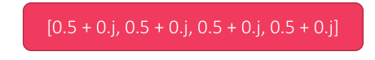

Figure 21

If the dimension of the feature vector is smaller than the number of

amplitudes, one can automatically pad it with a constant for the

missing dimensions using the pad_with option:

1. from math import sqrt

2. @qml.qnode(dev)

3. def circuit(f=None):

4. qml.AmplitudeEmbedding(features=f, wires=range(2), pad_with=0.)

5. return qml.expval(qml.PauliZ(0))

6. circuit(f=[1/sqrt(2), 1/sqrt(2)])

7. dev.state

8.

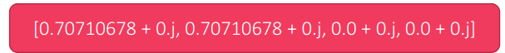

Figure 22

## Parameterized Section of Variational Quantum Circuits:

* Also called Ansatz.

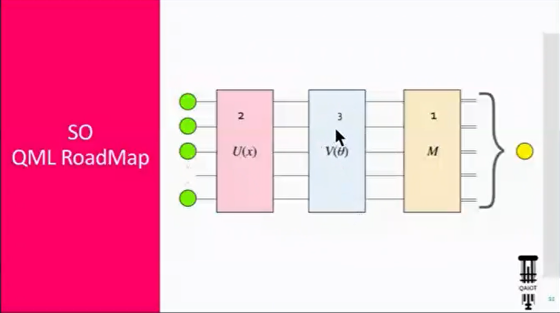

Figure 23

Layer architectures define sequences of trainable gates that are repeated like the layers in a neural network. Note that arbitrary templates or operations can also be repeated using the layer() function.

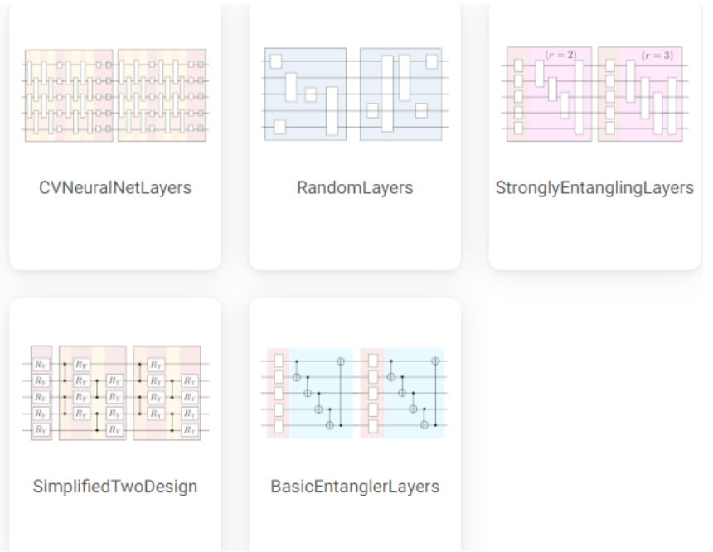

Figure 24

### Different type of Ansatz:

* Idle Circuit
* Circuit A
* Circuit B
* Arbitrary Unitary

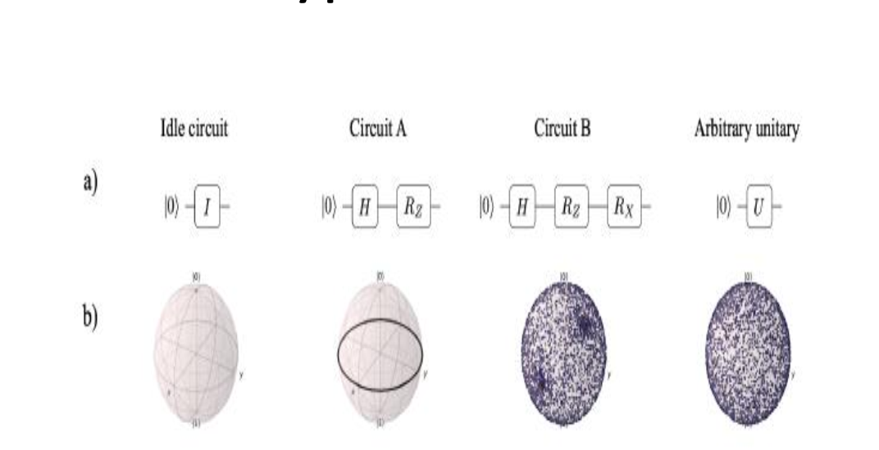

Figure 25

* There is a term called “Expressibility” and shows how much an “Ansatz” can be definitive in terms of explaining functions and their correlation.
* How strong an “Ansatz” is to define all available connections!
  + Low expressibility: Not going anywhere else except my initial State!

Adding More parameters allows for better expressibility but results in loss of generality and Overfit in your model!

We call this phenomena “Over Parametrization:.

* One of Weaknesses we have in this model is that we don’t have non-linearity despite Neural Networks. <Non-Linearity happens after Measurement>
* Simplest “Ansatz” is BasicEntangleMent:

### BasicEntangleMent:

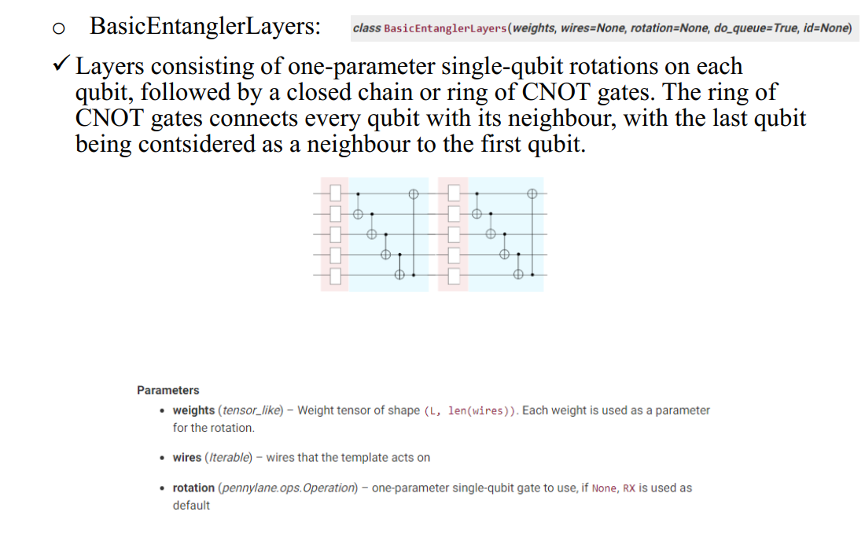

Figure 26

When Weights tensor is N*M it means that we have N layers and M wires in each layer. Each Wire has a parameterized gate in front of it< like Rotation gate>.

* What would happen if we didn’t have CNOT gates in each layer entangling different qubits to the other?
  + Then we would have a classical model and nothing more! We need to use superposition and entanglement in Quantum circuits.
* We need to have the potential of having entangled qbits but how much these qbits are entangled is up to the model and its design.

1. import pennylane as qml

2. from math import pi

3. n_wires = 3

4. dev = qml.device('default.qubit', wires=n_wires)

5. @qml.qnode(dev)

6. def circuit(weights):

7. qml.BasicEntanglerLayers(weights=weights, wires=range(n_wires),

8. rotation=qml.RX)

9. return [qml.expval(qml.PauliZ(wires=i)) for i in range(n_wires)]

10. circuit([[pi, pi, pi]])

11.

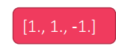

Figure 27

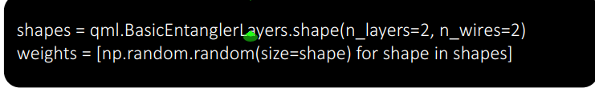

Figure 28

Custom Template:

from pennylane import numpy as np

def MyTemplate(a, b, wires):

c = np.sin(a) + b

qml.RX(c, wires=wires[0])

n_wires = 3

dev = qml.device('default.qubit', wires=n_wires)

@qml.qnode(dev)

def circuit(a, b):

MyTemplate(a, b, wires=range(n_wires))

return qml.expval(qml.PauliZ(0))

circuit(2, 3)

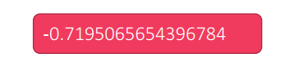

Figure 29

* Variable that shows how entangled parameters and qbits are:
  + Negativity-Von Neuman Entropy-Concerence
* Imprimitives are the gates that entangle qbits.
* Good Link to see for better understanding the concept of Layers and design depth: <https://m.youtube.com/watch?v=YpLzSQPrgSc> 🡪 QAOA Algorithm and …

## QAOA (Quantum Approximate Optimization Algorithm)

The Quantum Approximate Optimization Algorithm (QAOA) is a widely-studied method for solving combinatorial optimization problems on NISQ devices. The applications of QAOA are broad and far-reaching, and the performance of the algorithm is of great interest to the quantum computing research community.

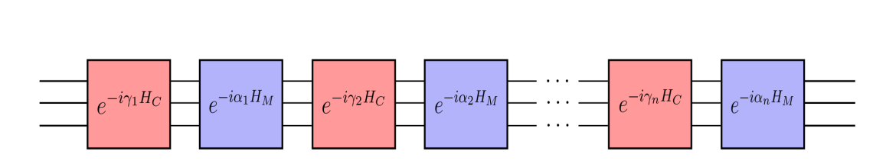

Figure 30

* Circuits and Hamiltonians:

When considering quantum circuits, it is often convenient to define them by a series of quantum gates. But there are many instances where it is useful to think of a quantum circuit in terms of a Hamiltonian. Indeed, gates are physically implemented by performing time evolution under a carefully engineered Hamiltonian.

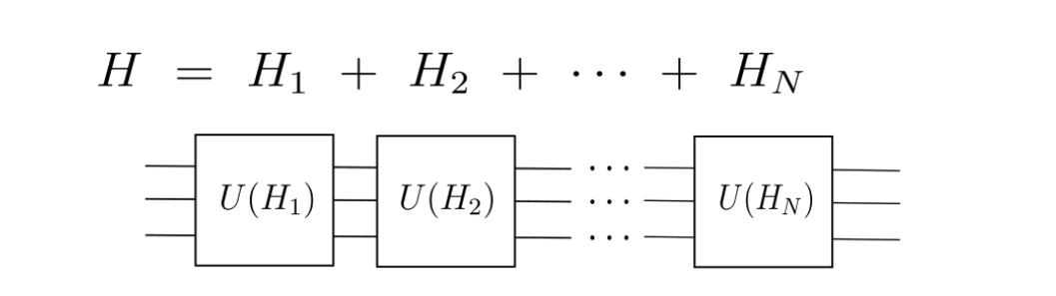

Figure 31

We have 2 kinds of Hamiltonian:

* **Cost** 🡪 Same Hamiltonian which if minimized, gives the ground state and the solution of the circuit.
* **Mixer** 🡪 Gives Randomness

Check this link for more information:

<https://www.youtube.com/watch?app=desktop&v=YpLzSQPrgSc>

How to define a Hamiltonian in pennylane:

import pennylane as qml

H = qml.Hamiltonian(

[1, 1, 0.5],

[qml.PauliX(0), qml.PauliZ(1), qml.PauliX(0) @ qml.PauliX(1)]

)

print(H)

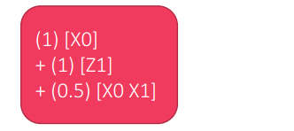

Figure 32

dev = qml.device('default.qubit', wires=2)

t = 1

n = 2

@qml.qnode(dev)

def circuit():

qml.ApproxTimeEvolution(H, t, n)

return [qml.expval(qml.PauliZ(i)) for i in range(2)]

print(qml.draw(circuit, expansion_strategy='device')())

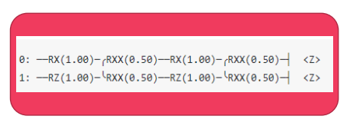

Figure 33

The quantum approximate optimization algorithm (QAOA) is a general technique that can be used to find approximate solutions to combinatorial optimization problems, in particular problems that can be cast as searching for an optimal bitstring. QAOA consists of the following steps:

1. Define a cost Hamiltonian (such that its ground state encodes the

solution to the optimization problem.)

2. Define a mixer Hamiltonian

3. Construct the circuits

4. Choose a parameter n

5. Prepare an initial state, apply U(γ,α) and use classical techniques to

optimize the parameters.

6. After the circuit has been optimized, measurements of the output

state reveal approximate solutions to the optimization problem.

* Example:

Minimum Vertex Cover with QAOA: Vertex covers can be represented by a bit string where each bit denotes whether the corresponding vertex is present in the cover. For example, the bit string 01010 represents a cover consisting of the second and fourth vertex in a graph with five vertices. The following schematic clarifies the idea.

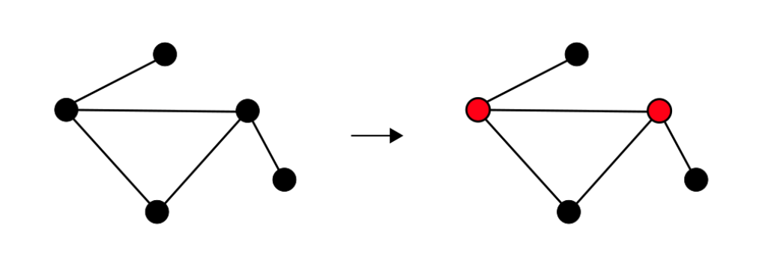

Figure 34

from pennylane import qaoa

from pennylane import numpy as np

from matplotlib import pyplot as plt

import networkx as nx

edges = [(0, 1), (1, 2), (2, 0), (2, 3)]

graph = nx.Graph(edges)

nx.draw(graph, with_labels=True)

plt.show()

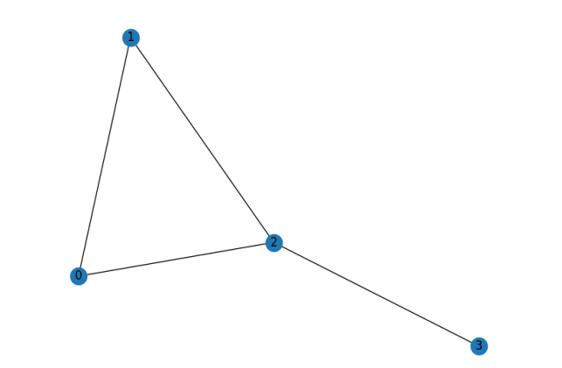

Figure 35

There are two minimum vertex covers of this graph: the vertices 0 and 2, and the vertices 1 and 2. These can be respectively represented by the bit strings 1010 and 0110. The goal of the algorithm is to sample these bit strings with high probability.

cost_h, mixer_h = qaoa.min_vertex_cover(graph, constrained=False)

print("Cost Hamiltonian", cost_h)

print("Mixer Hamiltonian", mixer_h)

def qaoa_layer(gamma, alpha):

qaoa.cost_layer(gamma, cost_h)

qaoa.mixer_layer(alpha, mixer_h)

wires = range(4)

depth = 2

def circuit(params, **kwargs):

for w in wires:

qml.Hadamard(wires=w)

qml.layer(qaoa_layer, depth, params[0], params[1])

dev = qml.device("qulacs.simulator", wires=wires)

@qml.qnode(dev)

def cost_function(params):

circuit(params)

return qml.expval(cost_h)

optimizer = qml.GradientDescentOptimizer()

steps = 70

params = np.array([[0.5, 0.5], [0.5, 0.5]], requires_grad=True)

for i in range(steps):

params = optimizer.step(cost_function, params)

print("Optimal Parameters")

print(params)

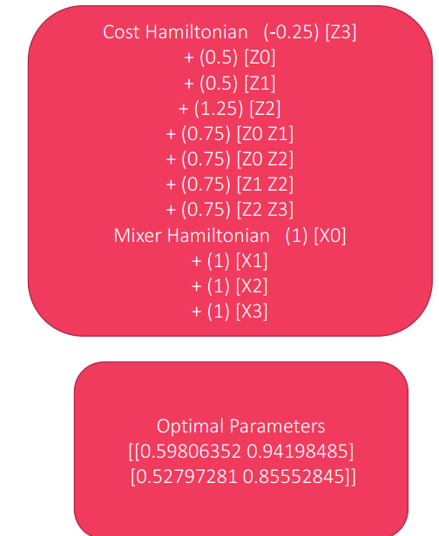

Figure 36

# An Introduction to the Quantum Approximation Optimization Algorithm and Applications

## Source: <https://www.youtube.com/watch?app=desktop&v=YpLzSQPrgSc>

### Agenda:

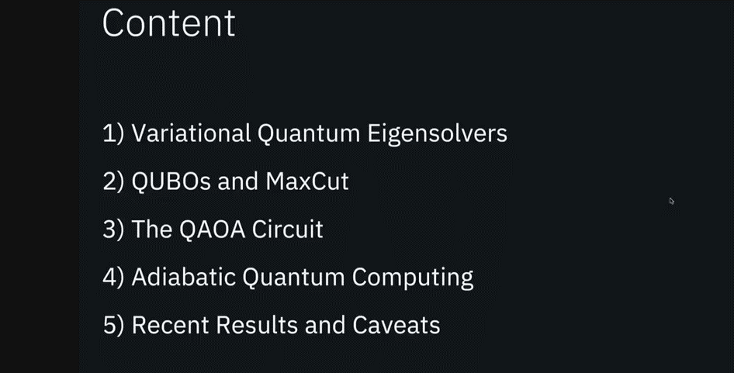

### Hamiltonian:

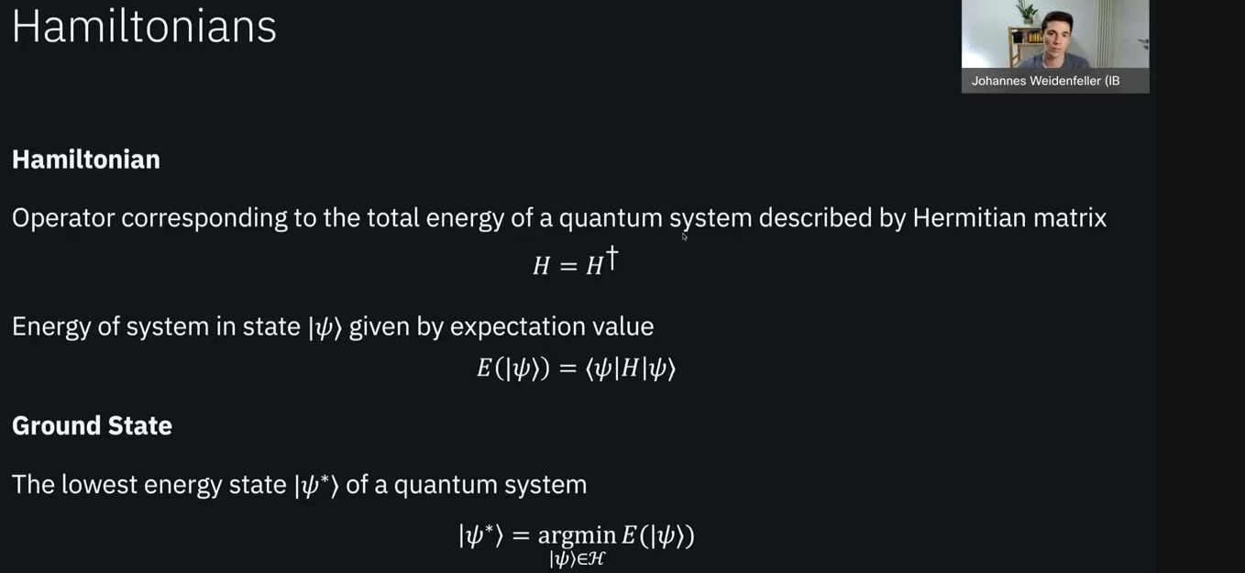

Figure 37

### The Variational Method

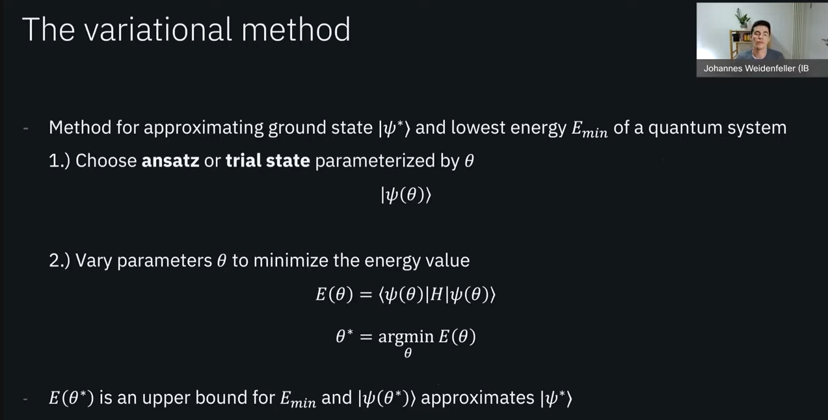

Figure 38

### Example of Parameterized Circuit:

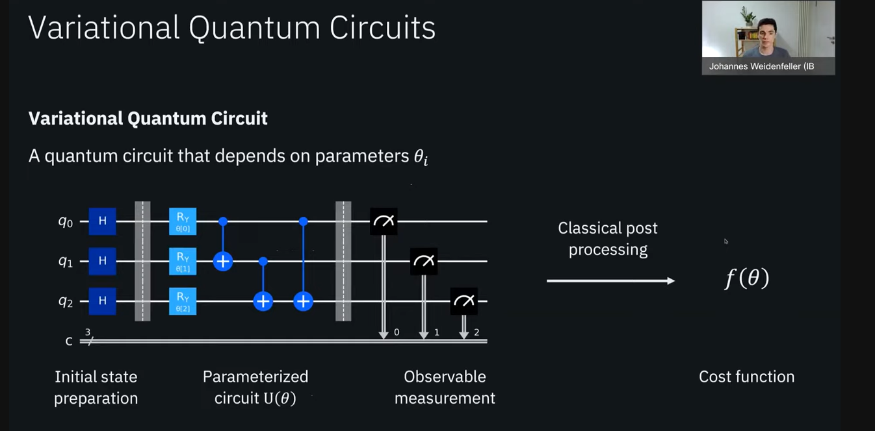

Figure 39

Variational Quantum Eigen Solvers:

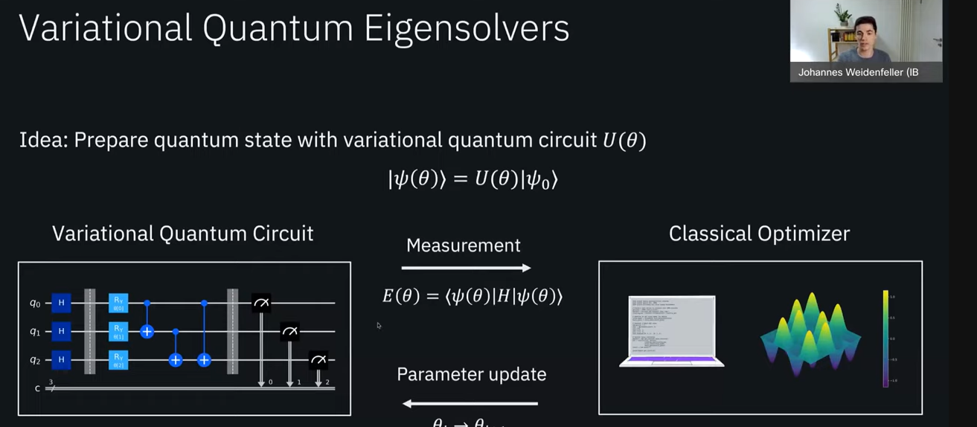

Figure 40

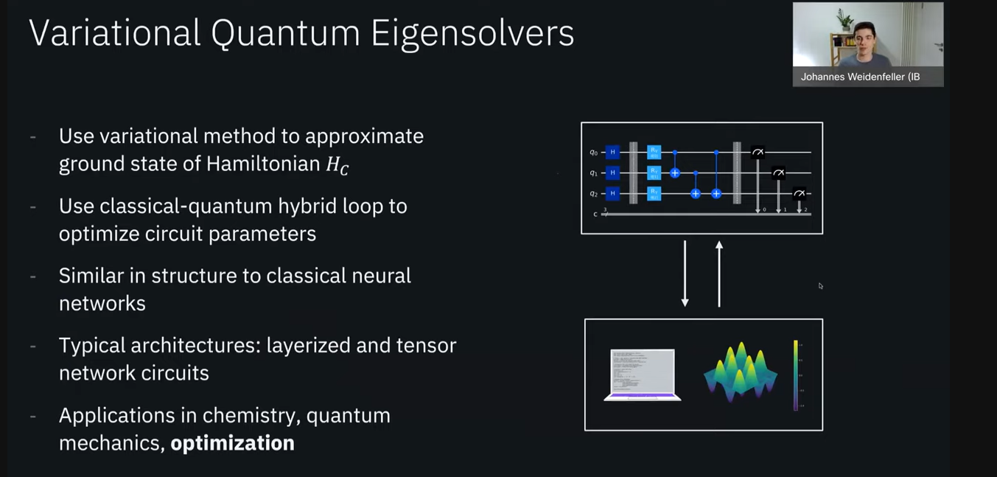

Figure 41

* Problems that can be solved with QAOA:
  + QUBO (Quadratic Unconstrained Binary Optimization)
  + MaxCut

### Quadratic Programs:

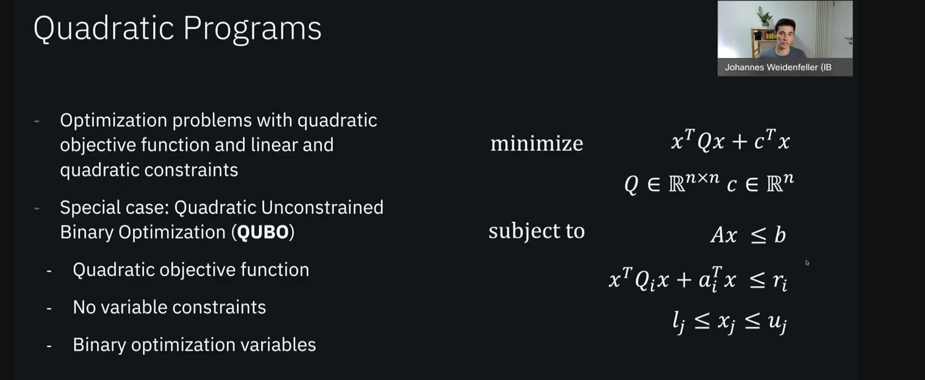

Figure 42

### MaxCut:

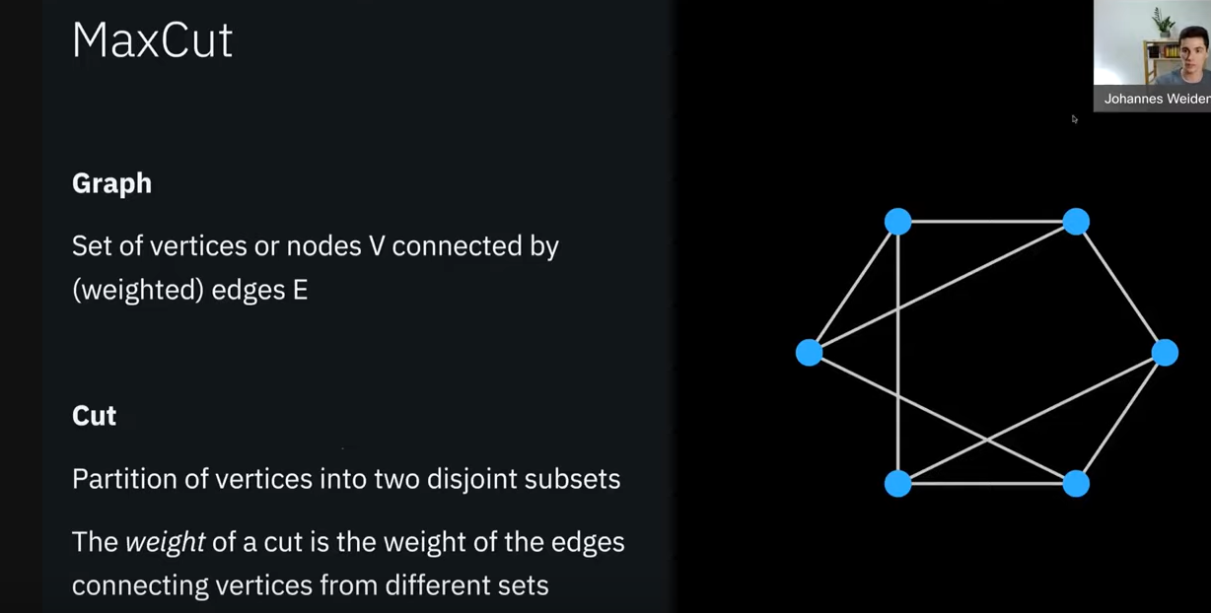

Figure 43

### MaxCut as QUBO:

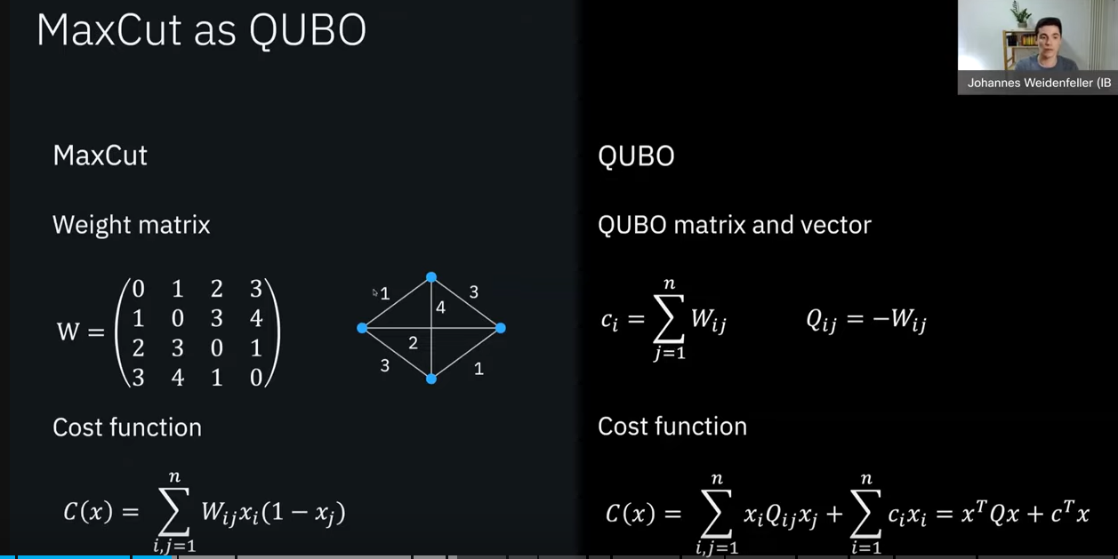

Figure 44

### MaxCut Classical Limitation:

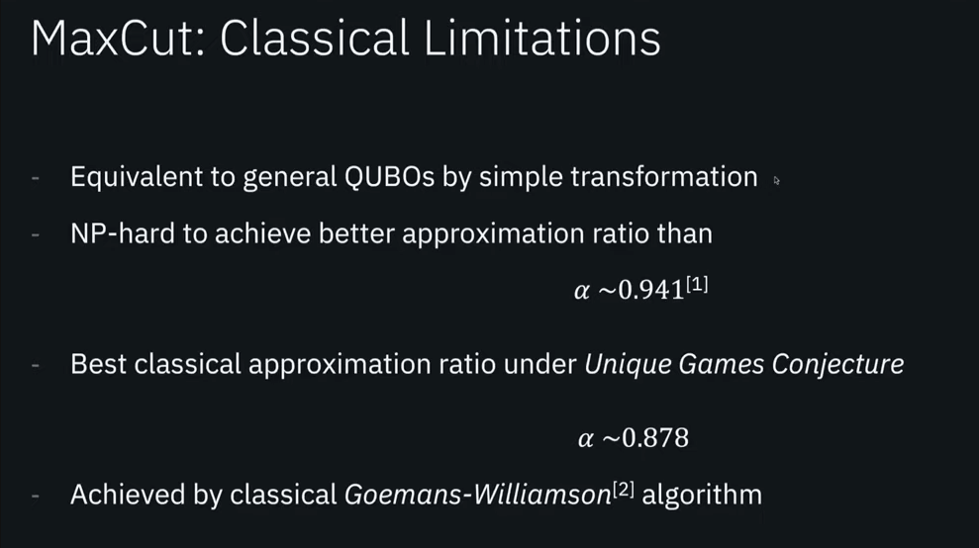

Figure 45

### Hamiltonian of the MaxCut problem:

Cost Function of MaxCut:

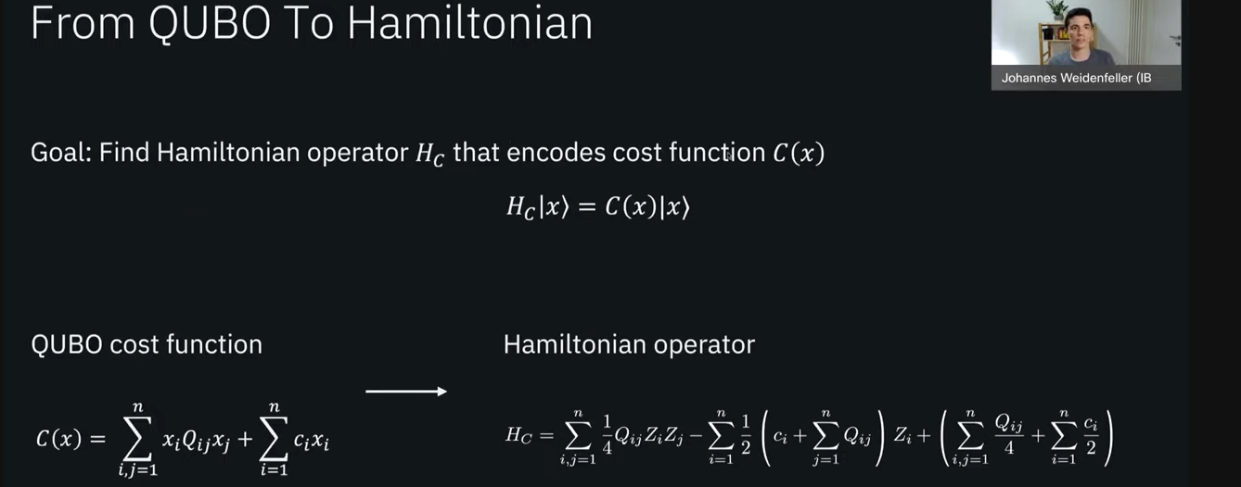

Figure 46

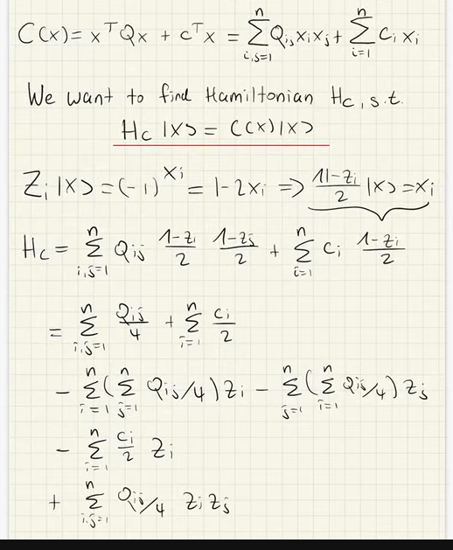

Figure 47

### QAOA Circuit:

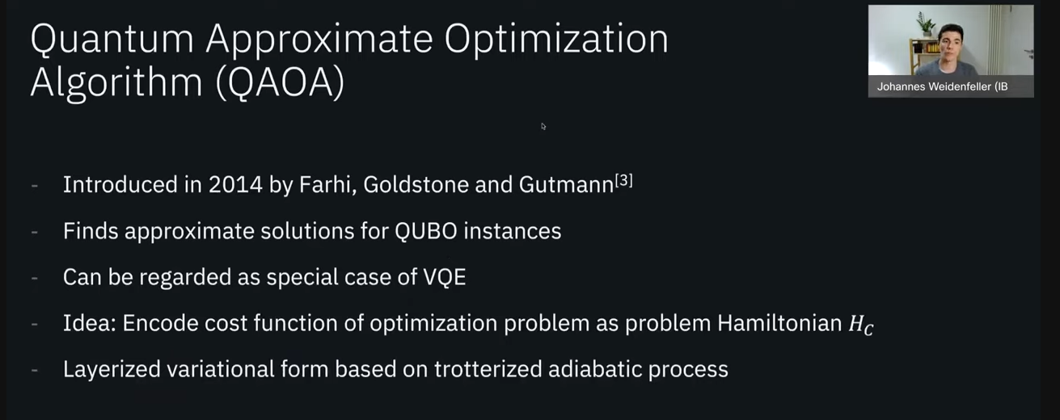

Figure 48

### QAOA Variational Form:

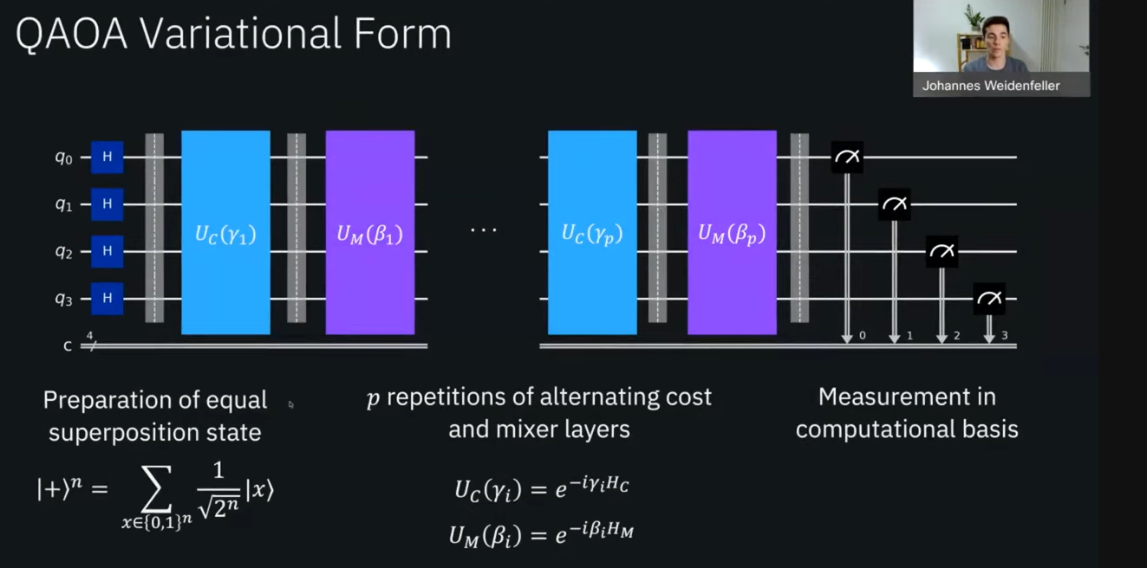

Figure 49

### Matrix Exponential:

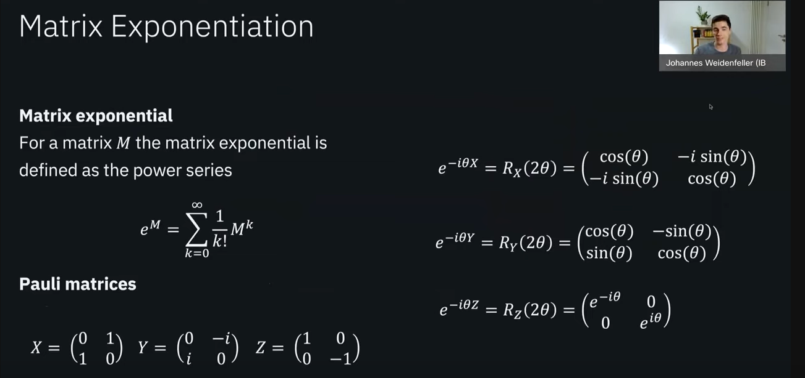

Figure 50

### QAOA Cost Layer:

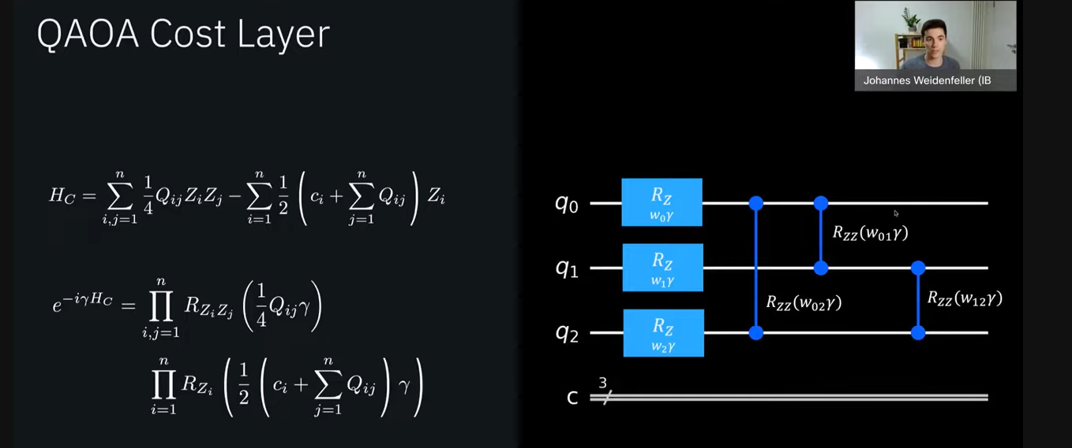

Figure 51

### Mixer Layer QAOA:

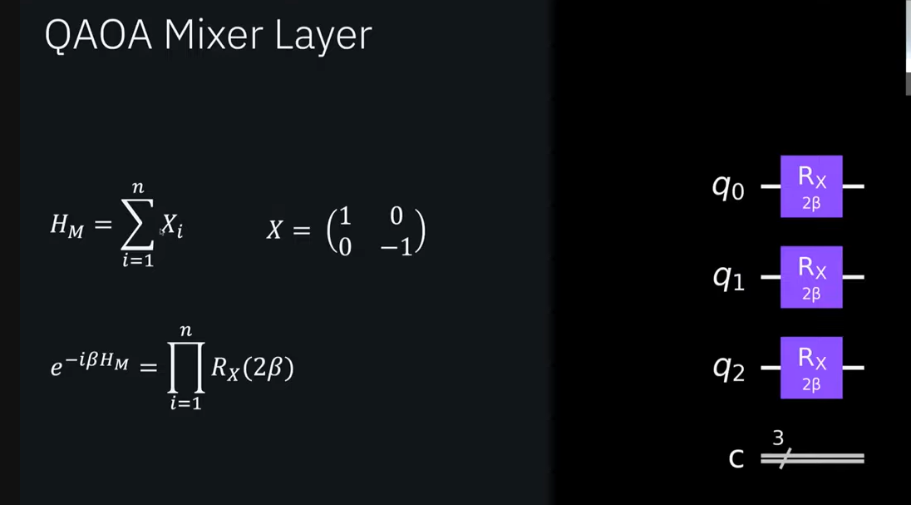

Figure 52

### QAOA Example:

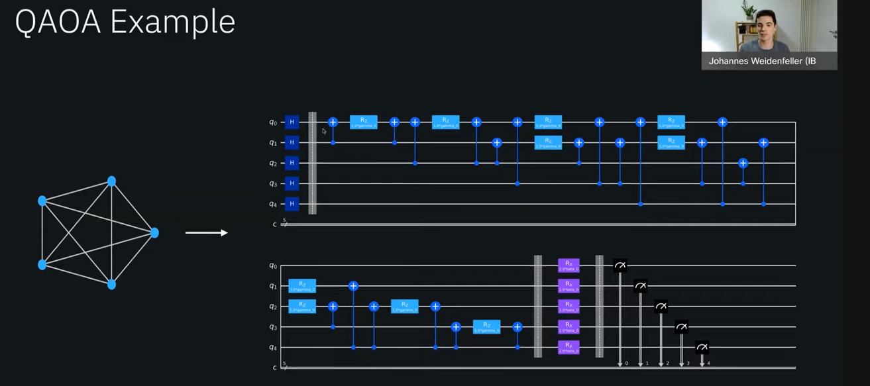

Figure 53

### Overall QAOA Flow:

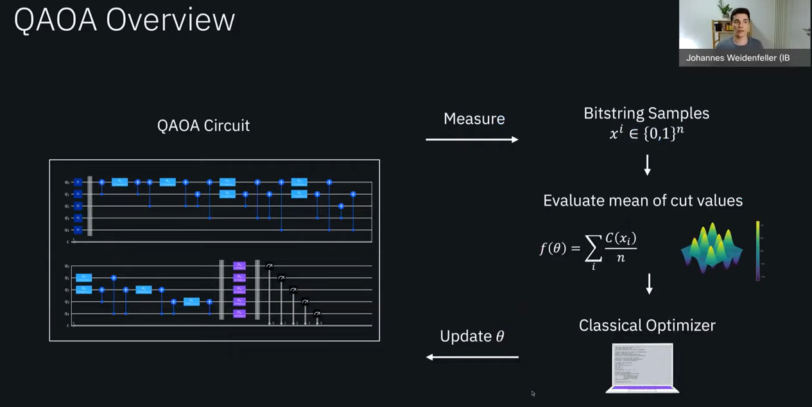

Figure 54

### QAOA Energy Landscape:

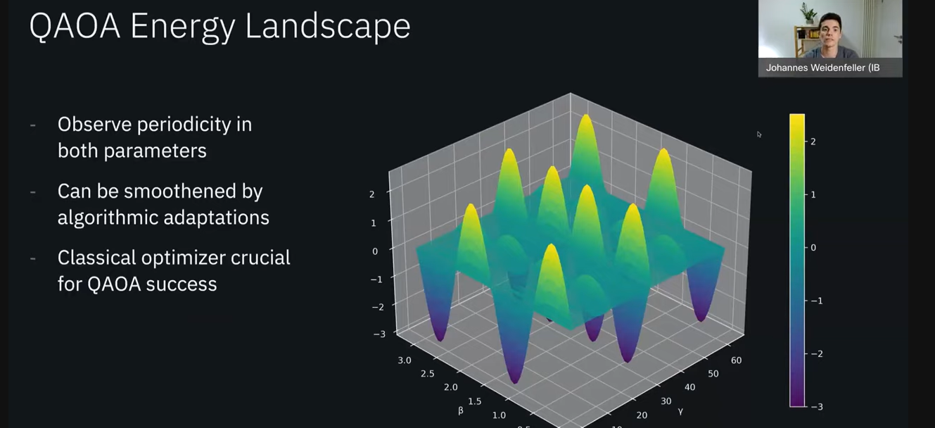

Figure 55

### Hamiltonian and Time-Evolution:

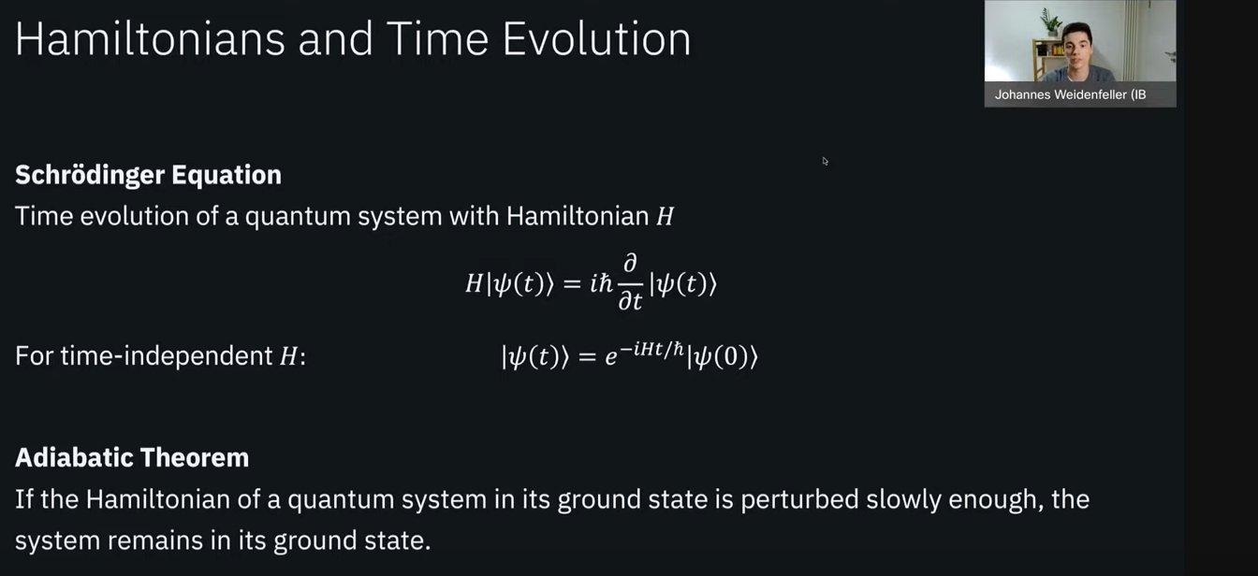

Figure 56

### Adiabatic Quantum Computing:

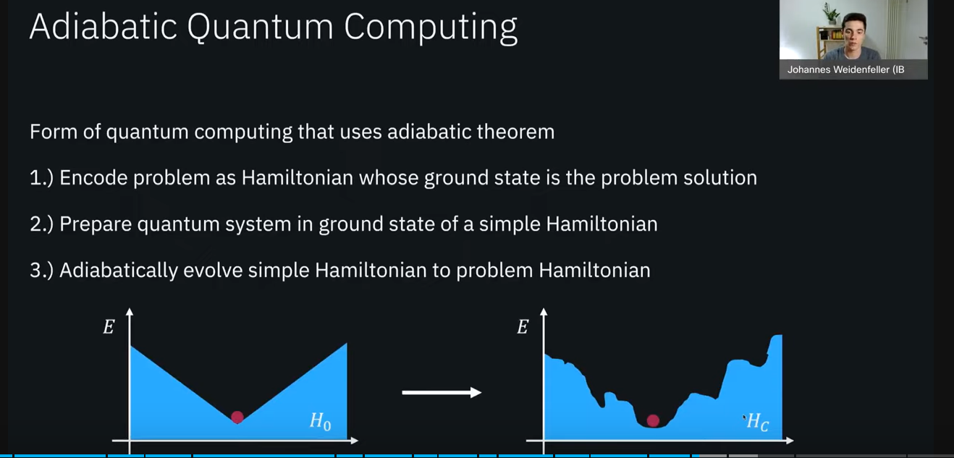

Figure 57

### Trotterization:

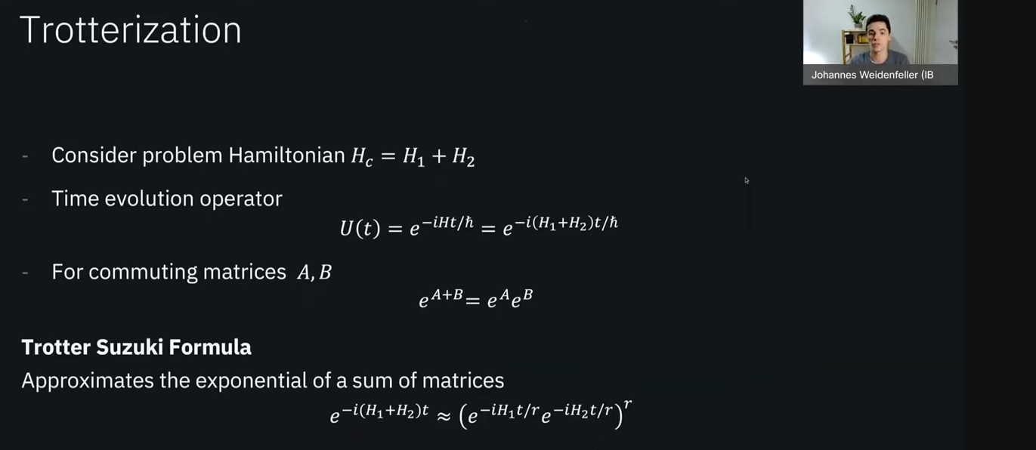

Figure 58

### Commuting Matrices:

From: <https://en.wikipedia.org/wiki/Commuting_matrices>

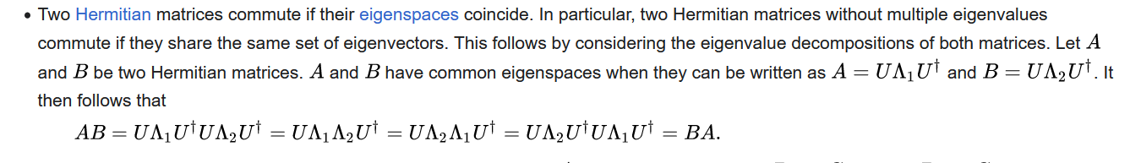

Figure 59

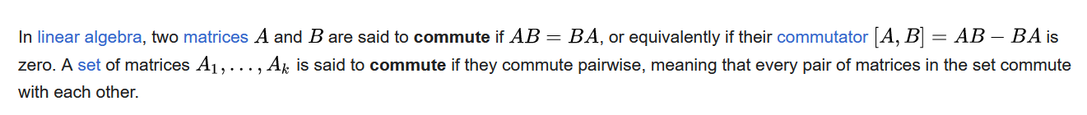

Figure 60

### QAOA as an Adiabatic Schedule:

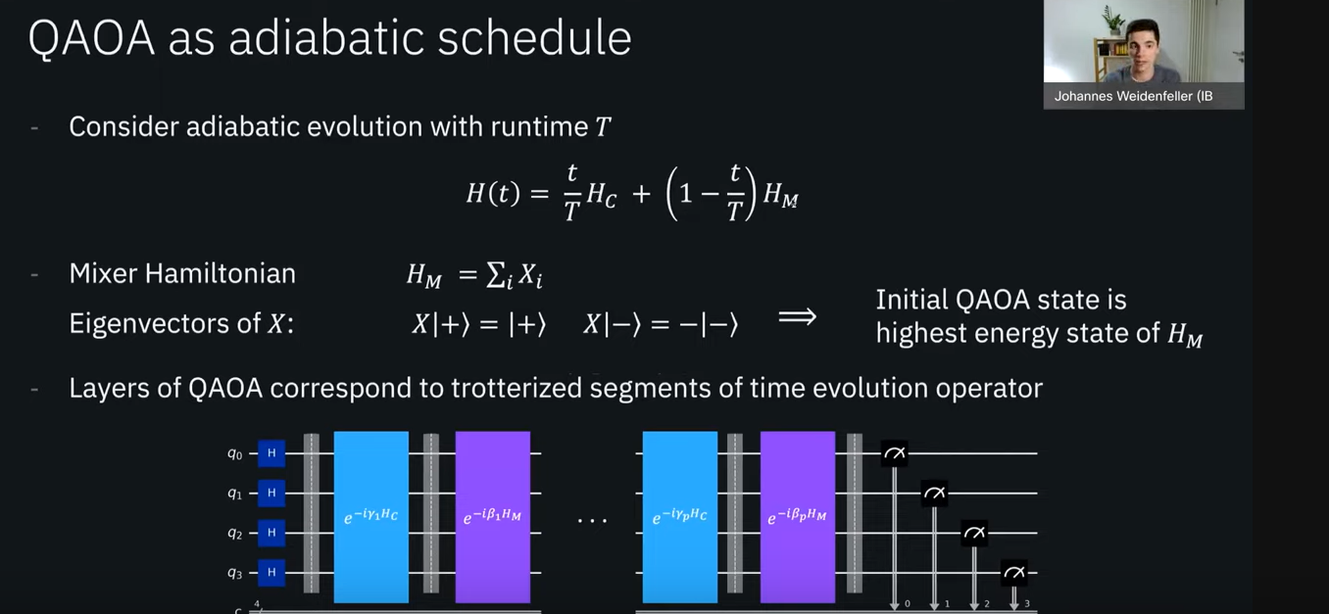

Figure 61

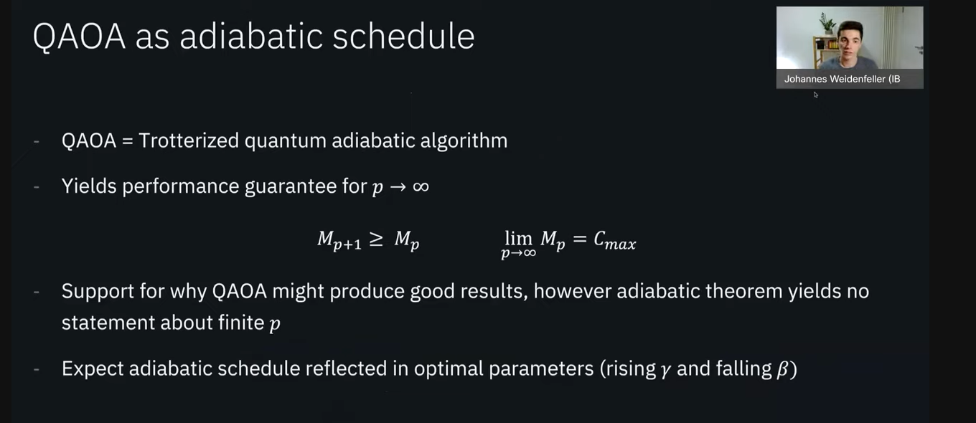

Figure 62

### Quantum Supremacy Condition:

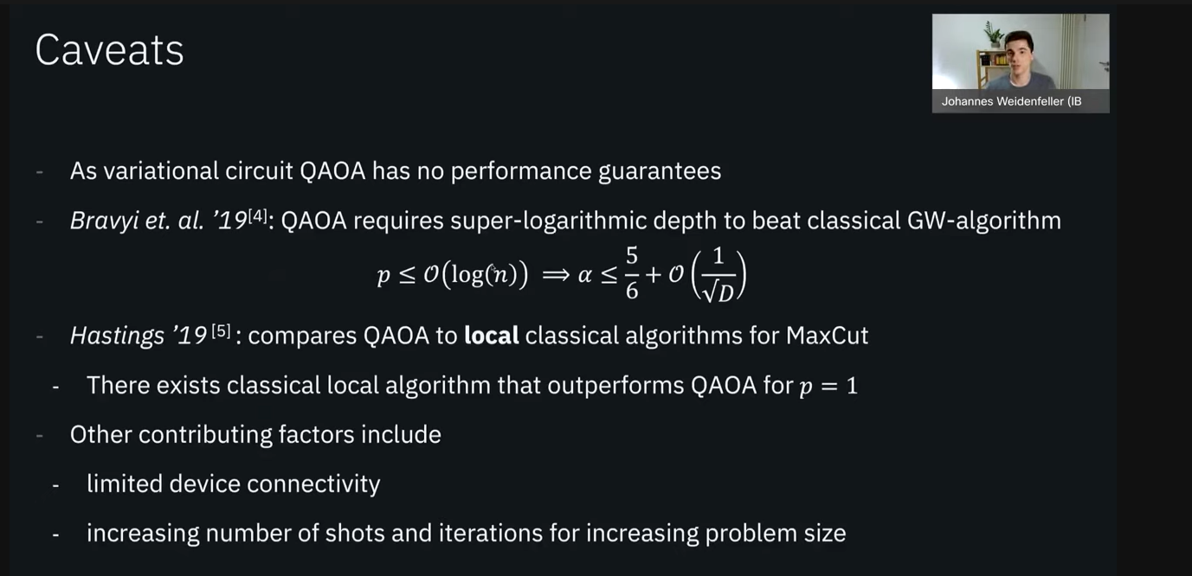

Figure 63

### CVaR to Speedup Algorithm:

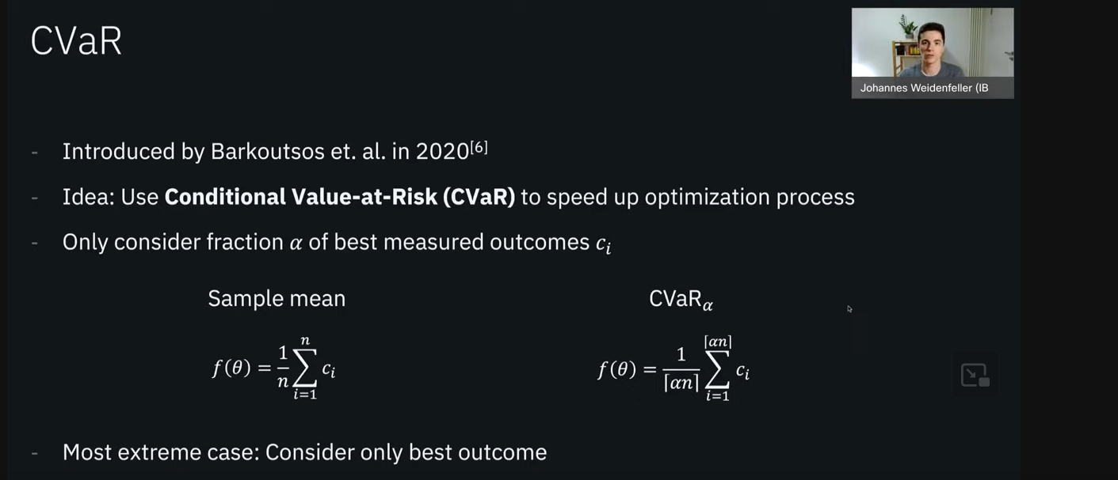

Figure 64

### Warm Starting QAOA:

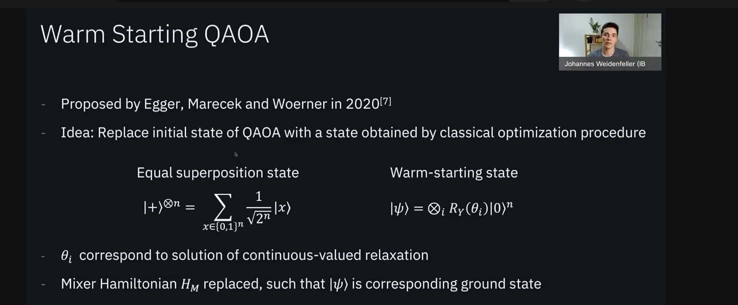

Figure 65

Parameter Concentration:

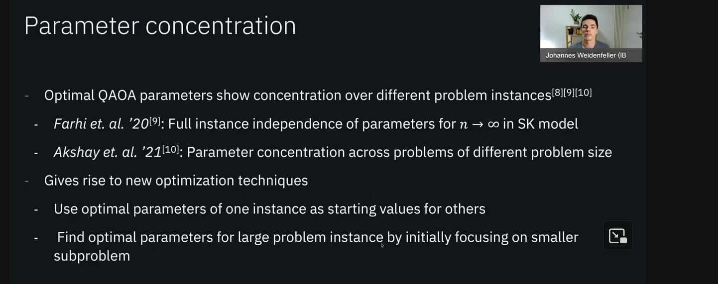

Figure 66

# Quantum SVM

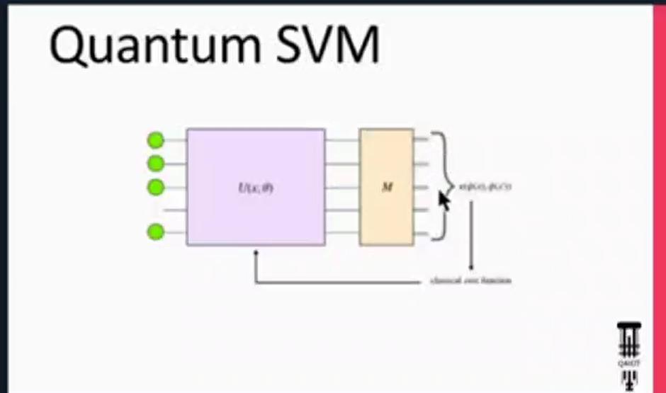

Figure 67

## Feature Map:

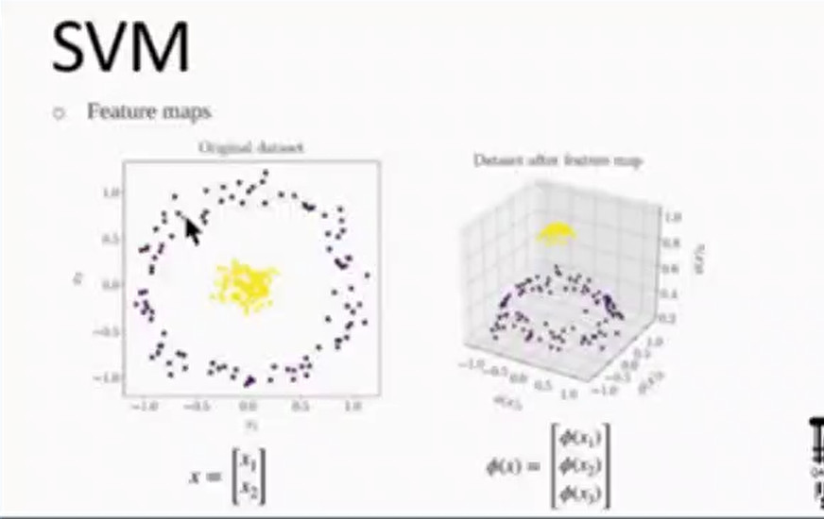

Figure 68

* Take the features into a higher dimension so that data are separable with a hyperplane.

## Kernel Function:

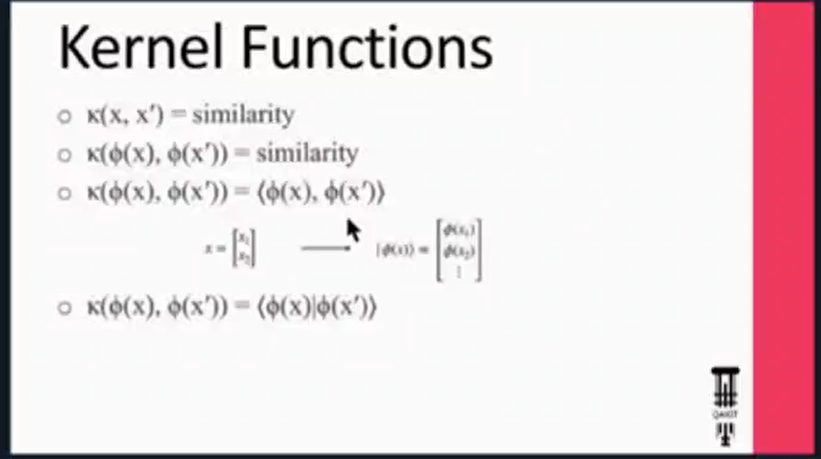

Figure 69

* Gives out similarity between 2 states or vectors or …

There are some features and KPIs that we can compare the quantum version of kernel with the Classical version.

One of the easiest methods available for inner product and similarity in quantum circuits is:

* **Swap Test:**

From: <https://www.educative.io/projects/find-the-inner-product-of-two-quantum-states-using-the-swap-test>

The SWAP test is a quantum algorithm used to find the similarity between two quantum states encoded on a quantum circuit. Apart from the quantum state registers, the SWAP test has a single qubit which, after the implementation of certain quantum operations, is measured to determine the results. The results of performing the SWAP test on the quantum states ∣a⟩ and ∣b⟩ are described by the following two equations:

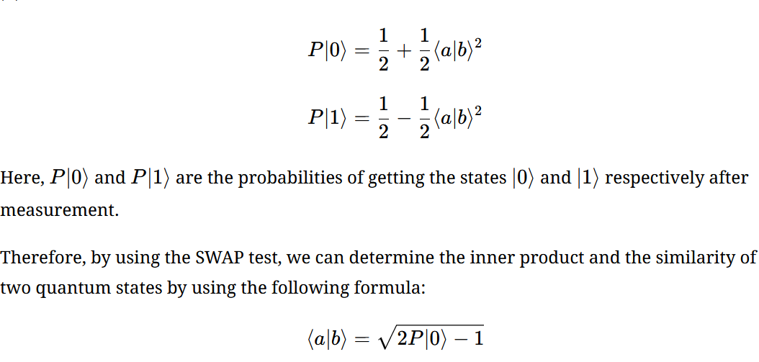

Figure 70

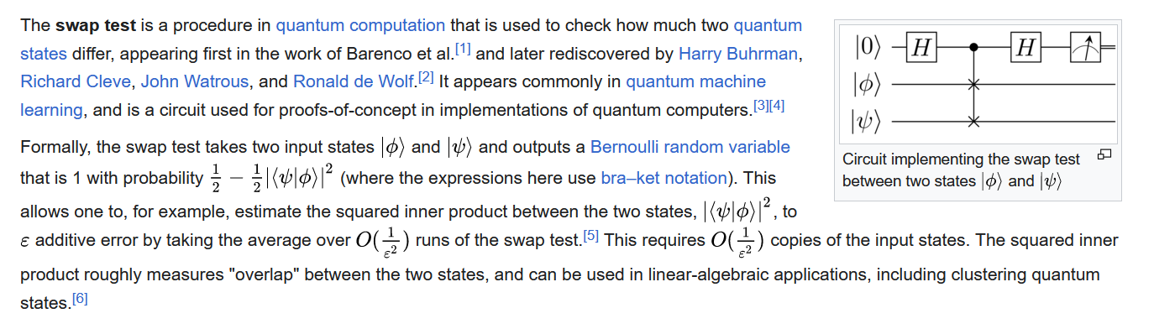

Figure 71

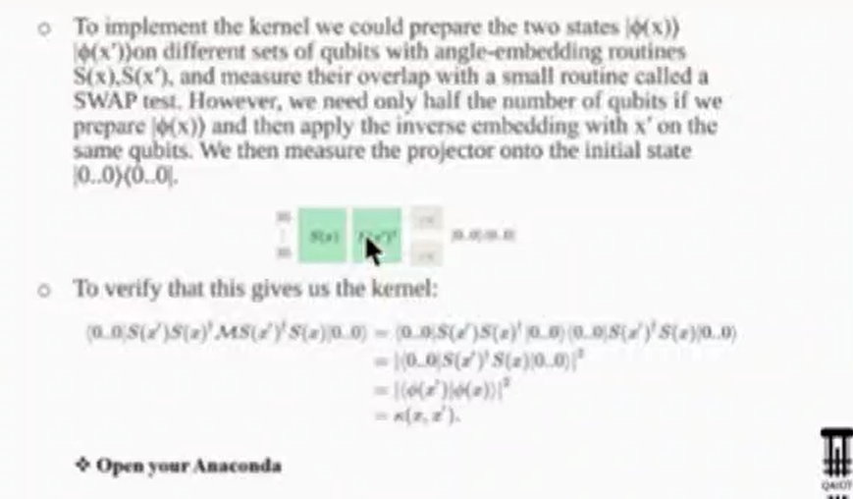

Figure 72

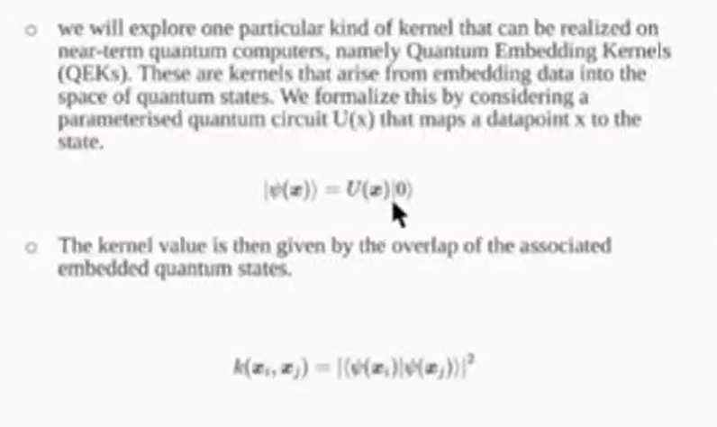

Figure 73

### QEK:

#### From: <https://arxiv.org/abs/2105.02276>

Kernel methods are a cornerstone of classical machine learning. The idea of using quantum computers to compute kernels has recently attracted attention. Quantum embedding kernels (QEKs) constructed by **embedding data into the Hilbert space** of a quantum computer are a particular quantum kernel technique that allows to gather insights into learning problems and that are particularly suitable for noisy intermediate-scale quantum devices. In this work, we first provide an accessible introduction to quantum embedding kernels and then analyze the practical issues arising when realizing them on a noisy near-term quantum computer. We focus on quantum embedding kernels with variational parameters. These variational parameters are optimized for a given dataset by increasing the kernel-target alignment, a heuristic connected to the achievable classification accuracy. We further show under which conditions noise from device imperfections influences the predicted kernel and provide a strategy to mitigate these detrimental effects which is tailored to quantum embedding kernels. We also address the influence of finite sampling and derive bounds that put guarantees on the quality of the kernel matrix. We illustrate our findings by numerical experiments and tests on actual hardware.

#### From: <https://journals.aps.org/pra/abstract/10.1103/PhysRevA.106.042431>

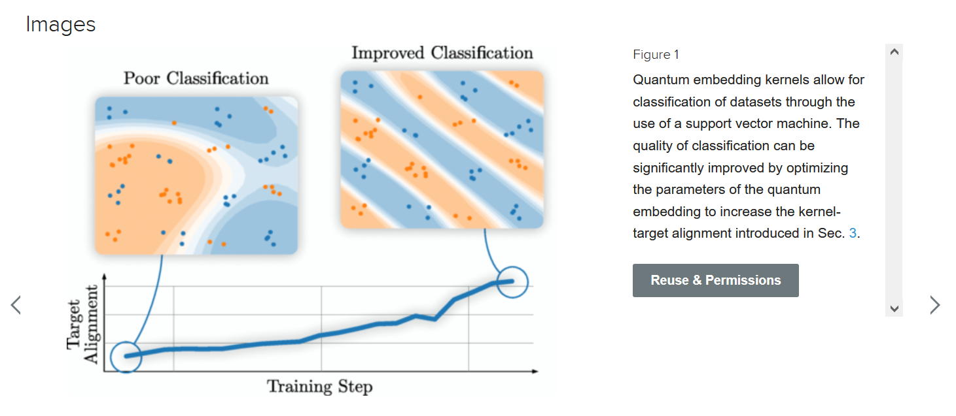

Figure 74

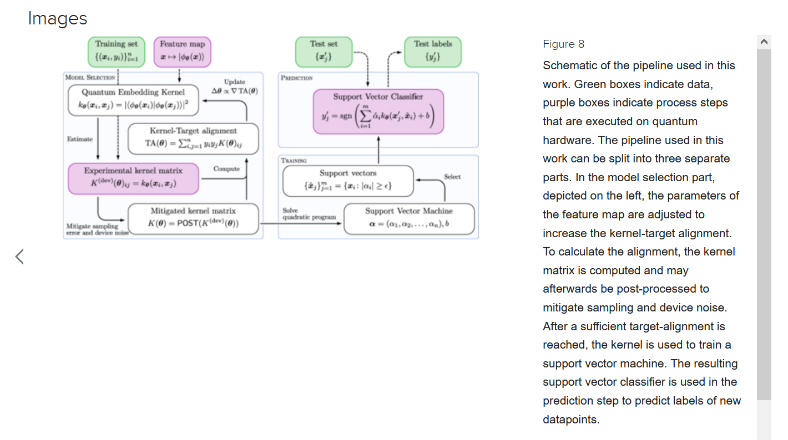

Figure 75

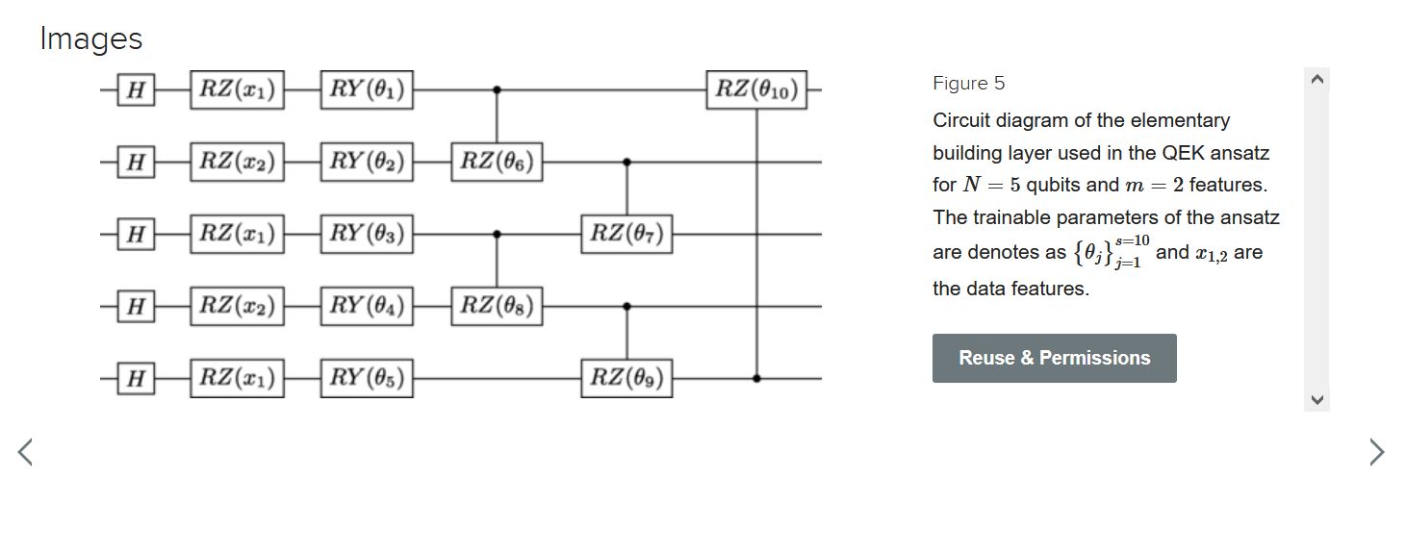

Figure 76

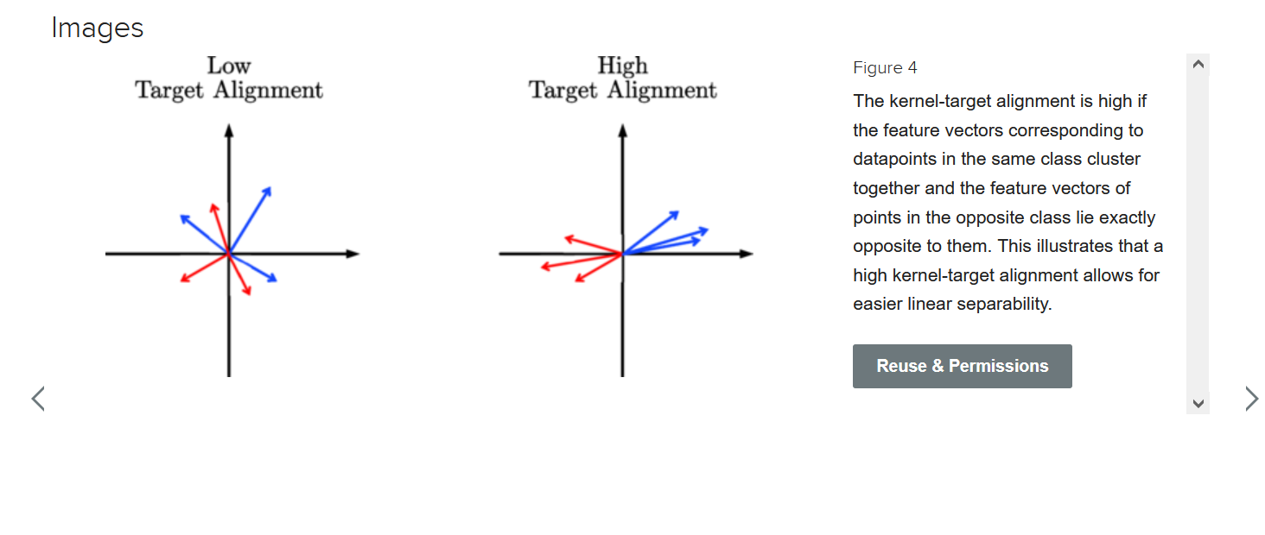

Figure 77

#### From: <https://pennylane.ai/qml/demos/tutorial_kernels_module>

PennyLane’s kernels module allows for a particularly simple implementation of Quantum Embedding Kernels. The first ingredient we need for this is an ansatz, which we will construct by repeating a layer as building block. Let’s start by defining this layer:

import pennylane as qml

def layer(x, params, wires, i0=0, inc=1):

"""Building block of the embedding ansatz"""

i = i0

for j, wire in enumerate(wires):

qml.Hadamard(wires=[wire])

qml.RZ(x[i % len(x)], wires=[wire])

i += inc

qml.RY(params[0, j], wires=[wire])  
  
 qml.broadcast(unitary=qml.CRZ, pattern="ring", wires=wires, parameters=params[1])

To construct the ansatz, this layer is repeated multiple times, reusing the datapoint x but feeding different variational parameters params into each of them. Together, the datapoint and the variational parameters fully determine the embedding ansatz U(x). In order to construct the full kernel circuit, we also require its adjoint U(x)†, which we can obtain via qml.adjoint.

def ansatz(x, params, wires):

"""The embedding ansatz"""

for j, layer_params in enumerate(params):

layer(x, layer_params, wires, i0=j * len(wires))

adjoint_ansatz = qml.adjoint(ansatz)

def random_params(num_wires, num_layers):

"""Generate random variational parameters in the shape for the ansatz."""

return np.random.uniform(0, 2 * np.pi, (num_layers, 2, num_wires), requires_grad=True)

Together with the ansatz we only need a device to run the quantum circuit on. For the purpose of this tutorial we will use PennyLane’s default.qubit device with 5 wires in analytic mode.

dev = qml.device("default.qubit", wires=5, shots=None)

wires = dev.wires.tolist()

Let us now define the quantum circuit that realizes the kernel. We will compute the overlap of the quantum states by first applying the embedding of the first datapoint and then the adjoint of the embedding of the second datapoint. We finally extract the probabilities of observing each basis state.

@qml.qnode(dev, interface="autograd")

def kernel_circuit(x1, x2, params):

ansatz(x1, params, wires=wires)

adjoint_ansatz(x2, params, wires=wires)

return qml.probs(wires=wires)

The kernel function itself is now obtained by looking at the probability of observing the all-zero state at the end of the kernel circuit – because of the ordering in qml.probs, this is the first entry:

def kernel(x1, x2, params):

return kernel_circuit(x1, x2, params)[0]

**Note**

An alternative way to set up the kernel circuit in PennyLane would be to use the observable type, **Projector**. This is shown in the demo on kernel-based training of quantum models, where you will also find more background information on the kernel circuit structure itself.

Before focusing on the kernel values we have to provide values for the variational parameters. At this point we fix the number of layers in the ansatz circuit to 6.

init_params = random_params(num_wires=5, num_layers=6)

Now we can have a look at the kernel value between the first and the second datapoint:

kernel_value = kernel(X[0], X[1], init_params)

print(f"The kernel value between the first and second datapoint is {kernel_value:.3f}")

The mutual kernel values between all elements of the dataset form the kernel matrix. We can inspect it via the qml.kernels.square_kernel_matrix method, which makes use of symmetry of the kernel, k(xi,xj)=k(xj,xi). In addition, the option assume_normalized_kernel=True ensures that we do not calculate the entries between the same datapoints, as we know them to be 1 for our noiseless simulation.

Overall, this means that we compute $\frac{1}{2}(N^{2}-N)$ kernel values for N datapoints. To include the variational parameters, we construct a lambda function that fixes them to the values we sampled above.

init_kernel = lambda x1, x2: kernel(x1, x2, init_params)

K_init = qml.kernels.square_kernel_matrix(X, init_kernel, assume_normalized_kernel=True)

with np.printoptions(precision=3, suppress=True):

print(K_init)

### Connectivity Concept:

From: <https://thequantuminsider.com/2023/07/10/why-qubit-connectivity-matters/>

Qubit connectivity is a crucial aspect of quantum computing because it determines how qubits can interact with each other. This interaction is necessary for performing quantum operations and executing quantum algorithms.

Here are a few reasons why qubit connectivity is important:

* Algorithmic Complexity: Many quantum algorithms require multiple qubits to interact with each other. The connectivity between qubits determines how efficiently these algorithms can be implemented. If qubits are not directly connected, additional operations may be needed to enable their interaction, which can increase the complexity and runtime of the algorithm.
* Error Correction: Quantum error correction codes, which are crucial for building reliable and practical quantum computers, often require specific patterns of connectivity between qubits. Good connectivity can make error correction more efficient and effective.
* Quantum Entanglement: Qubit connectivity is essential for creating quantum entanglement. If entanglement is desired between two non-connected qubits, a series of swap operations must be performed, increasingly the complexity and the chance of failure of the algorithm.
* Speed and Efficiency: The fewer operations a quantum computation needs, the faster it can be completed and the less chance there is for errors to creep in. If qubits are well-connected, fewer operations are needed to perform a computation, increasing the speed and efficiency of the quantum computer.

The connectivity varies greatly between various quantum modalities. Here are some examples of quantum architectures with high connectivity:

* Neutral atom quantum computers:
  + In a neutral atom computer, a cloud of atoms is trapped and cooled down to near absolute zero temperatures. Then, highly focused laser beams, “optical tweezers,” are used to move individual atoms around and to perform quantum operations. By adjusting the arrangement of the laser beams, one can control which atoms interact with each other, allowing for a high degree of flexibility in the connectivity between qubits. See a video and a more detailed explanation of qubit shuttling here.
* Trapped Ion quantum computers:
  + In trapped ion quantum computers, ions are held in place by electromagnetic fields and qubits are encoded in stable electronic states of each ion. All qubits can interact with each other, providing full connectivity.
* Photonic quantum computers, which use particles of light (photons) as qubits, can theoretically have high connectivity. This is because photons can easily interact with each other through beam splitters and other optical elements.

Here are some examples of quantum architectures with low connectivity:

* Superconducting quantum computers:
  + In superconducting quantum computers, qubits are arranged in a 2D grid, and each qubit can only interact with its nearest neighbors, which are typically two or three qubits. The qubits are fixed and cannot move.
* Quantum annealers:
  + In quantum annealers, qubits are also arranged in a 2D structure called with fixed connectivity. For instance, in a D-Wave computer, this structure is referred to as a Chimera graph, where each qubit is connected to six other qubits.

Of course, high-connectivity architectures are not without disadvantages. High connectivity relies on the ability to shuttle qubits around, and shuttling qubits carries several potential issues. Shuttling qubits can be a relatively slow process compared to the speed of quantum gate operations. This can increase the total computation time and reduce the number of operations that can be performed before the qubits lose coherence. The process of moving qubits introduces the risk of decoherence, which is the loss of the quantum state due to interaction with the environment. Shuttling qubits also adds an extra layer of complexity to the design of the computer, and this can be challenging to implement, especially in a large-scale system.

In summary, qubit connectivity plays a vital role in the performance and functionality of quantum computers. It impacts the implementation of quantum algorithms, the creation of quantum entanglement, error correction, and the overall scalability, speed, and efficiency of quantum computing systems. When one considers the quantum modality of choice for their application, qubit connectivity should be one of the factors taken under consideration.

### Bandwidth Concept:

From: <https://aakinshin.net/posts/kde-bw/>

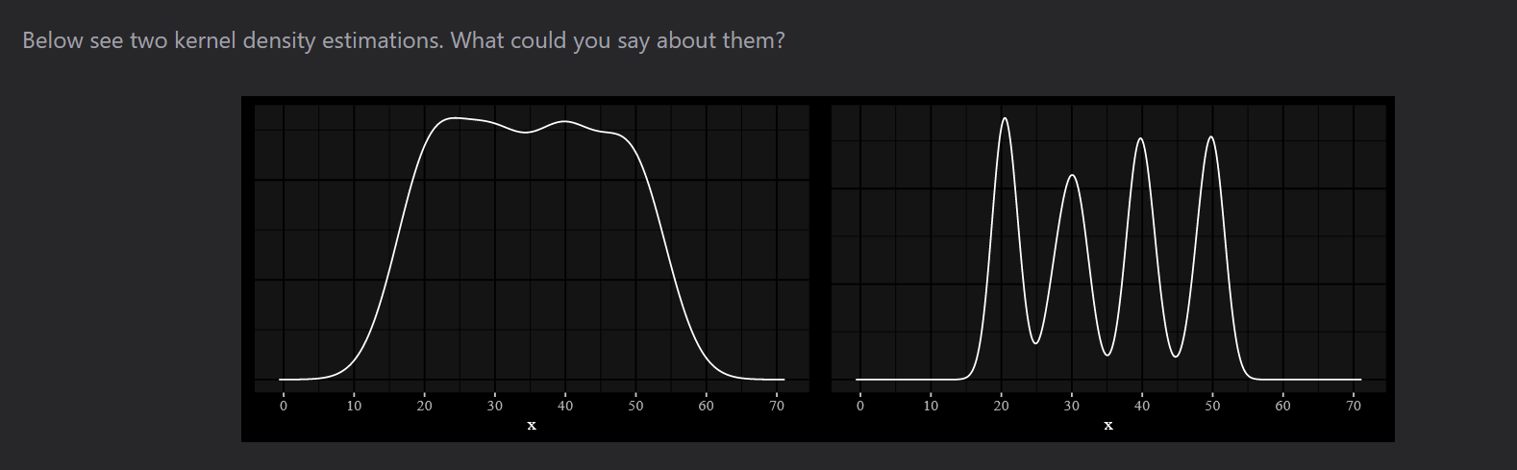

Figure 78

Most likely, you say that the first plot is based on a uniform distribution, and the second one is based on a multimodal distribution with four modes. Although this is not obvious from the plots, both density plots are based on the same sample:

**The only difference between plots is in bandwidth selection!**

### Kernel density estimation

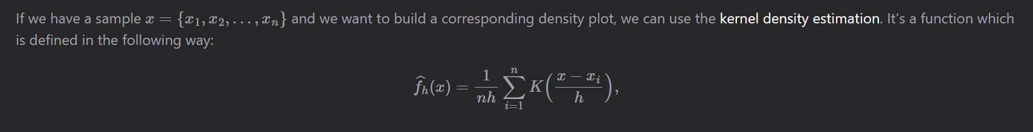

Figure 79

where

* K is the kernel (a simple non-negative function like the normal or uniform distribution),
* h is the bandwidth (a real positive number that defines smoothness of the density plot).

A poorly chosen bandwidth value may lead to undesired transformations of the density plot:

* A small bandwidth leads to undersmoothing.
* It means that the density plot will look like a combination of individual peeks (one peek per each sample element).
* A huge bandwidth leads to over-smoothing.
* It means that the density plot will look like a unimodal distribution and hide all non-unimodal distribution properties (e.g., if a distribution is multimodal, we will not see it in the plot).

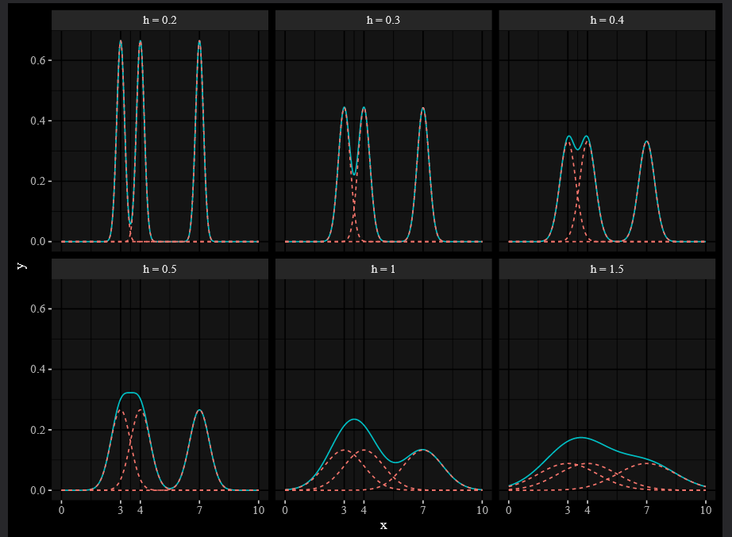

Figure 80

The bigger bandwidth we set, the smoother plot we get.  
Let’s analyze what happens with increasing the bandwidth:

• h=0.2: the kernel density estimation looks like a combination of three individual peaks

• h=0.3: the left two peaks start to merge

• h=0.4: the left two peaks are almost merged

• h=0.5: the left two peaks are finally merged, but the third peak is still standing alone

• h=1: the two merged peaks start to absorb the third peak, but the distribution is still bimodal

• h=1.5: no signs of multimodality, we have a wide and smooth unimodal distribution

So, we need an algorithm that chooses the optimal bandwidth value and avoids over-smoothing and undersmoothing.

Such an algorithm is called **bandwidth selector** (or **bandwidth estimator**). Let’s look at some popular selectors that we can use. I start with the 40-element sample from the beginning of the post and bandwidth selectors available in standard R functions.

Below you can see density plots that are drawn using different built-in bandwidth selectors from R:

* bw.nrd0 (Silverman’s rule of thumb),
* bw.nrd (Scott’s rule of thumb),
* bw.bcv (biased cross-validation),
* bw.ucv (unbiased cross-validation),
* bw.SJ (Sheather & Jones method), and

manual (you can just set any constant that you want).

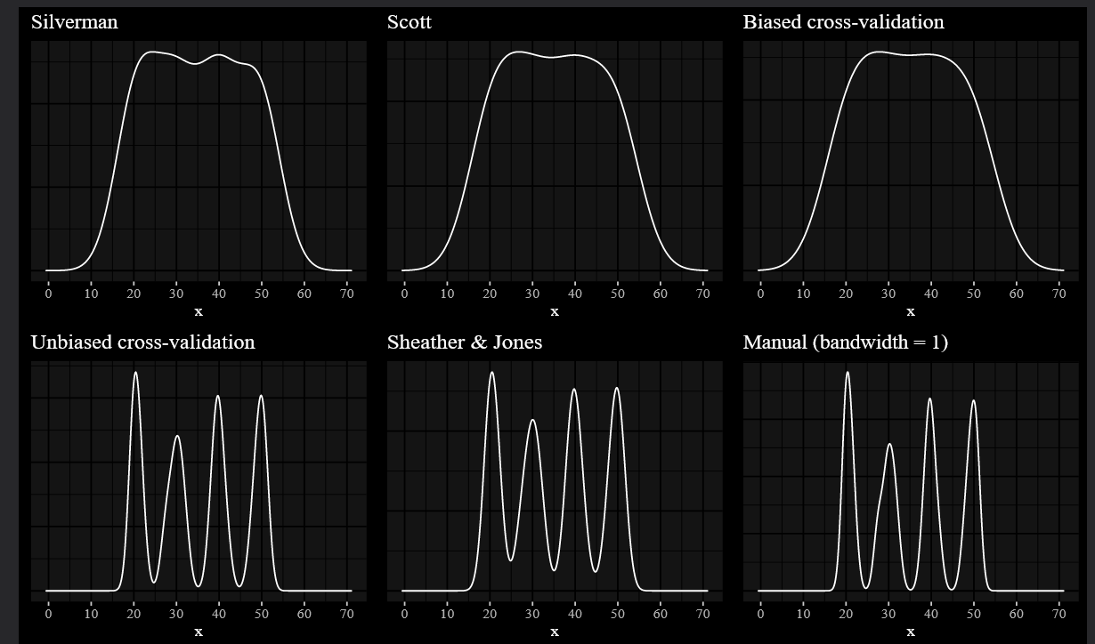

Figure 81

Although they are simple and easy to compute, they have limitations. The first one requires the data from the normal distribution. If you work with another kind of distribution, you will not get meaningful results using Scott’s rule of thumb. The second rule is more robust but, as we can see, it doesn’t work well in complicated cases.

* However, if you are not sure about the form of your distribution, you may need a non-parametric bandwidth selector. Here are a few examples of existing selectors:

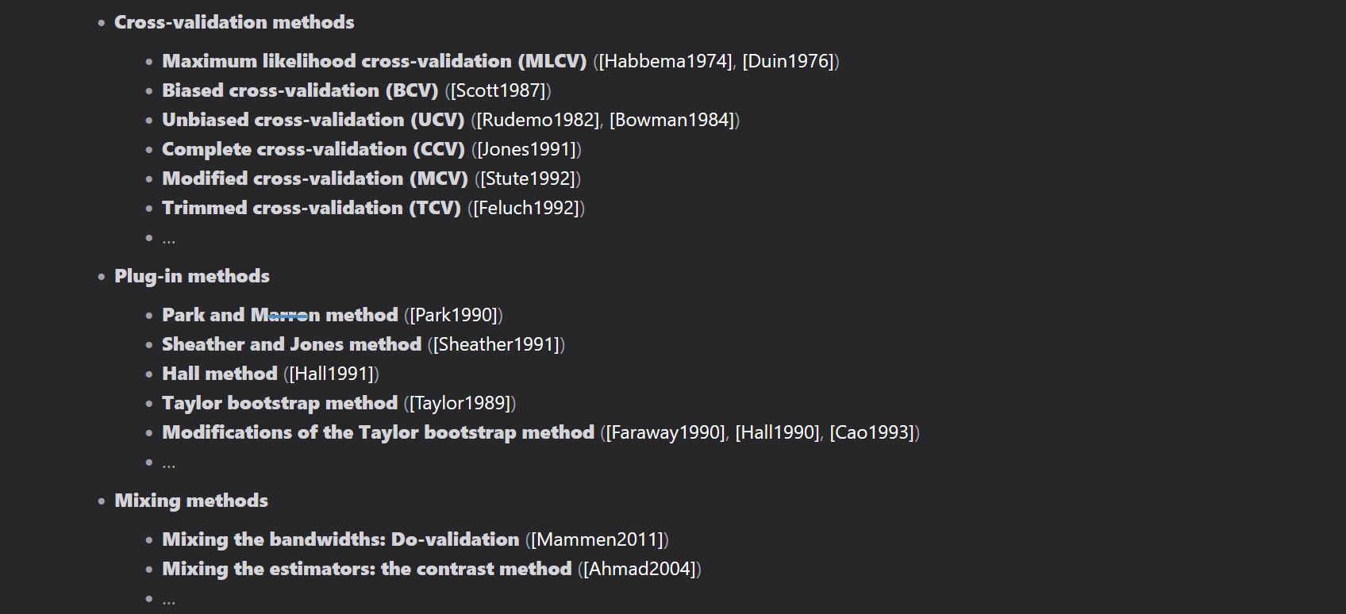

Figure 82

Conclusion

There are many different bandwidth selectors that you can use in kernel density estimation. Unfortunately, the default bandwidth selector in your favorite statistical package may lead to wrong visualizations. To avoid problems with data interpretation, I recommend three simple rules:

Be aware of the bandwidth selector that you use

You shouldn’t blindly use the default value from your favorite statistical package. It would be better to carefully think about the used bandwidth selector and explain to yourself why it fits your data. It would be much better if you share this explanation together with your density plots.

Use a non-parametric bandwidth selector if you don’t know the underlying distribution

My personal recommendation is the Sheather and Jones method (e.g., bw.SJ in R, "SheatherJones" in Wolfram Mathematica, bandwidth_SJ in Matlab). However, you can use any bandwidth selector that you want while you understand why you apply this particular selector and while you are sure that it fits your situation.

Double-check that the data actually fits the density estimation

You can never be sure that your estimation is correct until you verify it. It’s OK to use estimation plots without additional checks during research, but it’s always a good idea to double-check it before you publish/report/apply/use it.

References

* [Scott1992]
  + Scott, D. W. (1992) Multivariate Density Estimation: Theory, Practice, and Visualization. New York: Wiley.
* [Silverman1986]
  + Silverman, B. W. (1986). Density Estimation. London: Chapman and Hall.
* [Sheather1991]
  + Sheather, S. J. and Jones, M. C. (1991). A reliable data-based bandwidth selection method for kernel density estimation. Journal of the Royal Statistical Society series B, 53, 683–690. http://www.jstor.org/stable/2345597.
* [Guidoum2015]
  + Guidoum, Arsalane Chouaib. “Kernel estimator and bandwidth selection for density and its derivatives.” The kedd package, version 1 (2015).
* [Heidenreich2013]
  + Heidenreich, Nils-Bastian, Anja Schindler, and Stefan Sperlich. “Bandwidth selection for kernel density estimation: a review of fully automatic selectors.” AStA Advances in Statistical Analysis 97, no. 4 (2013): 403-433.
* [Schindler2012]
  + Schindler, Anja. “Bandwidth selection in nonparametric kernel estimation.” (2012).
* [Habbema1974]
  + Habbema, J. D. F., Hermans, J., and Van den Broek, K. (1974). A stepwise discrimination analysisprogram using density estimation.Compstat 1974: Proceedings in Computational Statistics.Physica Verlag, Vienna.
* [Duin1976]
  + Duin, R. P. W. (1976). On the choice of smoothing parameters of Parzen estimators of probabilitydensity functions.IEEE Transactions on Computers,C-25, 1175–1179.
* [Duin1976]
  + Scott, D.W. and George, R. T. (1987). Biased and unbiased cross-validation in density estimation.Journal of the American Statistical Association,82, 1131–1146.
* [Rudemo1982]
  + Rudemo, M. (1982). Empirical choice of histograms and kernel density estimators.ScandinavianJournal of Statistics,9, 65–78.
* [Bowman1984]
  + Bowman, A. W. (1984). An alternative method of cross-validation for the smoothing of kerneldensity estimates. Biometrika,71, 353–360.
* [Jones1991]
  + Jones, M. C. and Kappenman, R. F. (1991). On a class of kernel density estimate bandwidthselectors. Scandinavian Journal of Statistics,19, 337–349
* [Stute1992]
  + Stute, W. (1992). Modified cross validation in density estimation. Journal of Statistical Planningand Inference,30, 293–305.
* [Feluch1992]
  + Feluch, W. and Koronacki, J. (1992). A note on modified cross-validation in density estimation.Computational Statistics and Data Analysis,13, 143–151.
* [Park1990]
  + Park, B.U., Marron, J.S.: Comparison of data-driven bandwidth selectors. J. Am. Stat. Assoc.85, 66–72(1990)
* [Hall1991]
  + Hall, P., Sheater, S.J., Jones, M.C., Marron, J.S.: On optimal databased bandwidth selection in kernel densityestimation. Biometrika 78, 263–269 (1991)
* [Taylor1989]
  + Taylor, C.C.: Bootstrap choice of the smoothing parameter in kernel density estimation. Biometrika76,705–712 (1989)
* [Faraway1990]
  + Faraway, J.J., Jhun, M.: Bootstrap choice of bandwidth for density estimation. J. Am. Stat. Assoc.85,1119–1122 (1990)
* [Hall1990]
  + Hall, P.: Using the bootstrap to estimate mean square error and select smoothing parameters in nonparametricproblems. J. Multivar. Anal.32, 177–203 (1990)
* [Cao1993]
  + Cao, R.: Bootstrapping the mean integrated squared error. J. Multivar. Anal.45, 137–160 (1993)
* [Mammen2011]
  + Mammen, E., Martínez-Miranda, M.D., Nielsen, J.P., Sperlich, S.: Do-validation for kernel density estima-tion. J. Am. Stat. Assoc.106, 651–660 (2011)
* [Ahmad2004]
  + Ahmad, I.A., Ran, I.S.: Data based bandwidth selection in kernel density estimation with parametric start via kernel contrasts. J. Nonparametr. Stat.16, 841–877 (2004)

# BB84 Cryptography:

Figure 83

BB84 is a quantum key distribution (QKD) protocol developed by Charles Bennett and Gilles Brassard in 1984. It is one of the most widely studied QKD protocols and is considered to be one of the most secure.

The BB84 protocol uses photons to transmit quantum bits (qubits) between two parties, Alice and Bob. Alice randomly chooses a basis, either rectilinear (horizontal/vertical) or diagonal, and sends a qubit to Bob.

* Bob also randomly chooses a basis and measures the qubit. If Alice and Bob choose the same basis, they will get the same result.
* If they choose different bases, they will get different results.

Alice and Bob can then use the results of their measurements to establish a shared secret key. If an eavesdropper, Eve, tries to eavesdrop on the communication, she will disturb the qubits and Alice and Bob will be able to detect her presence.

The BB84 protocol is considered to be secure against all known attacks, including quantum attacks. However, it is important to note that no QKD protocol is perfectly secure. There is always a small chance that an eavesdropper could still obtain the secret key.

The BB84 protocol is a significant breakthrough in quantum cryptography. It has the potential to revolutionize the way we communicate and share information.

Here are some of the advantages of the BB84 protocol:

* It is provably secure against all known attacks, including quantum attacks.
* It is relatively easy to implement.
* It is scalable to long distances.

Here are some of the disadvantages of the BB84 protocol:

* It requires a high-quality quantum source.
* It is susceptible to noise.
* It is not yet commercially available.

Overall, the BB84 protocol is a promising QKD protocol with a lot of potential. It is still under development, but it has the potential to revolutionize the way we communicate and share information.

# Notes:

* Quantum logic gates are represented by unitary matrices.
* A gate which acts on n qubits is represented by a $2^{n}×2^{n}$ unitary matrix, and the set of all such gates with the group operation of matrix multiplication is the symmetry group U(2*n*).
* The quantum states that the gates act upon are unit vectors in $2^{n}$ complex dimensions, with the complex Euclidean norm (the 2-norm).
* The basis vectors (sometimes called *eigenstates*) are the possible outcomes if measured, and a quantum state is a linear combination of these outcomes.
* The most common quantum gates operate on vector spaces of one or two qubits, just like the common classical logic gates operate on one or two bits.
* **Hamiltonian**: Potential+ Kintetic Energy | Square Matrix which is equal to its Hermitian
  + **An observable that describes the whole system’s energy**.
  + **Internal and external interactions of a system**.
  + **Expectation value from a Hamiltonian gives the energy in the system**.
  + **If I use Hamiltonian of the system instead of RX and RY, and then take the expectation value from the system🡪 This is like I’m trying to find where I have the ground state or the state with minimum energy or |0>.**
  + Pauli matrices are Potentially good Options for Hamiltonian!